INNOVATION FOR ENTREPRENEURS
Class #: ______________

Professor: Class: 2 hrs/week
Office: Classroom:
E-mail: Tel:

Office Hours:

Course Description

In this course you will learn how to innovate to solve problems in the world around you. The project work you will do can serve as the foundation for a new venture. And at the same, engaging in innovation is a wonderful way to discover your strengths, your career passions, and make a new set of friends, who just might be your partners in a new venture in the not-too-distant future.

Mindful, impact-focused innovation!

This course is divided into four sections: a) thinking about problems experienced by people of far-ranging and different types; b) finding classmates who have shared interests in a particular set of problems; c) using methods to deeply understand the users’ needs and frustrations as the basis for innovation; and d) to design clever, robust solutions for these people in order to solve their problems. Each section has key frameworks and templates for you to complete, improving your idea step by step until the final presentation.

First, you learn the major types of innovation and how they can serve as the basis for new ventures and also impact society in beneficial ways. Next, you will consider different problem spaces in which to venture and then select one upon which to focus for the course, based on your interests and natural skills. These problems healthcare, learning, food and nutrition, energy use, more efficient transportation, smart buildings, sports and personal health management, media and entertainment, and many others. Then, we will help you team with other students with a similar passion for a particular problem area and skills that are complementary to yours. With teams formed, you learn specific design methods for creating new products and services. These methods include customer discovery, driving user needs into well-architected designs, competitive analysis, market sizing, prototyping designs, and concept testing your designs. Whether you become an entrepreneur, or a product manager or innovative engineer in a larger company, these methods will become your playbook that you can use time and time again.

Our teaching method is experiential and highly project-based. And throughout the chapters, we illustrate the methods with a variety of examples from our students’ ventures around the world. These ventures were selected for their impact in health, nutrition, and environment. You will enjoy and be inspired by their accomplishments, plus learn the methods through their experiences..

Course Objectives
Students will have the opportunity to:
- Explore innovation problem space based on your personal interests, areas of study, and social purpose
- Learn how to come up with new ideas for innovation and test them
- Learn a set of essential methods to conduct customer immersions, do structured product and service design, and engage in rapid concept design and new product and service prototyping
- See how these methods apply to designing new products, new systems such as mobile apps, and new services.
- Gain rich experience applying the innovation process to solve real-world problems .
- Develop solutions to these problems that can serve as the basis for your own venture.
- Feel the job and satisfaction of working in a team to tackle some of society’s most pressing problems through innovation and entrepreneurship.

Course Materials
- Meyer and Lee (2022), Innovation for Entrepreneurs, Edward Elgar Publishing, Cheltenham, UK and Northampton, MA, USA.
- Additional readings
- Additional videos, including case studies and customer interviewing methods

Expectations of you in the classroom: Each student is expected to be prepared to discuss the readings/exercises assigned for each class. It’s not optional! Students will be randomly asked to discuss and summarize the material. Your learning in this course is heavily dependent upon your willingness to participate actively in class discussions. Your class participation will be assessed on the quality and consistency of your effort in each and every class.

Late assignments: Late assignments will be graded accordingly. Let you teacher know if you are having difficulties meeting a deadline.

Presentations: Achieving success with an innovative idea requires you to package and present the idea in a crisp, creative, and powerful manner. The activity of presenting helps you to focus your ideas and improve them with feedback. There will be two major presentations during the course, plus a series of other smaller unscheduled presentations of work in progress or course material. Prepare, practice, and succeed!

Time spent outside of class: The course is hands-on and requires students to conduct field research through direct interactions with people (interviews/surveys) and online/in the library. Specifically, the course requires that students conduct studies with potential target users/buyers and stakeholders. You must be prepared to go out of your comfort zone to dig for information. You will need to search for information online and arrange to meet with or talk to relevant people who may have the information you need.

Group Project Overview

This is a semester-length project and the cornerstone component of the course. The group project will give you the opportunity to apply the course concepts to a real situation. You will learn about the entrepreneurship for your own business or your work in organizations. Even if you are not going to be an entrepreneur, you need to know how to identify the opportunities, who to persuade, and how to create economic and social values in many different contexts.

Talking to customers is one of the most important steps in investigating your business because your entrepreneurial vision must correspond to a true market opportunity. With your group, you will interview successive waves of potential users for your innovations. At first, you will interview just two or three people to focus in on a new product or service idea; then another 10 users to dive deeply into their needs and frustrations; and then another 10 users to show and receive feedback on initial designs; and last, hopeful another 10 users to get feedback on early prototypes. These are “customer immersions” in both the place of purchase (such as a store) and in the place of use. Finally, towards the end of the book, you will do a more formal survey of approximately 30 target users to confirm the “Customer Value Proposition” and better understand how and where you target customers buy products and services like yours. Think of this as a Reality Check on all your work for the semester.

“Design” is fun, particularly when you merge customer insight with your own creativity. This can be a highly enjoyable as well as meaningful course. Pick a good problem to solve with innovation, which for many of you might improve the human, societal, and/or climate condition.

For the final outcome, you will be required to come up with a presentation that can be used as the basis for actually starting a venture based on an impactful innovation. Once again, we provide a specific format and the tools for creating a compelling pitch. Most of all, we want you to think about an exciting proposition that is more than just about making money, but rather, one that helps society. This will give your innovation and venture concept a greater lift with customers – and at the same time, make you feel good, deep inside.

Project Components and Grading

100%
90
80
70
60
50
40
30
20
10

Personal Innovation Reflection Journal
(15%)

Personal Discovery Reflection (15%)

Individual
Class Engagement
(10%)

Group Project
- Ideation and Team (5%)
- Customer Interview & Insight (20%)
- Concept Design & Test (20%)
- Reality Check, Prototypes, and Final Pitch (30%)

Team

Deliverables

There are a number or different deliverables for the course that follow the templates presented in the book, as applied to your innovation idea. Do your best to keep up with the timeline of the class: do not fall behind! Later templates build on the learnings from prior templates. Make the most of your team! Everyone needs to pitch in. In no case should one person be taking the lead on all templates. Rather, different team members should take the lead on specific deliverables. Coordinate well, and let your teacher know if a team member is not carrying his or her load.

Specific Deliverables

Ideation and Team Hand-in Package: 5% of total grade
Should be clearly written, with a one-page explanation for the team’s decision

User/Buyer Interviews and Insight Hand-in Package: 20% of total grade
(1st round of user interviews)
- Target User/Buyer Template
- Latent Needs and Full Use Case Template
- Persona Template for Users (and buyers if different than users)
- Customer Value Proposition Template

Concept Design (and User Walkthroughs) Hand-in Package: 20% of total grade
(2nd round of user interviews)
- Competitive Analysis Template
- Product Vision and Subsystem Design Templates
- Reality Check Survey Template and Results

Reality Check, Prototypes and Final Pitch: 30% of total grade
- Reality Check Survey and statistical results
- Prototypes
- Final presentation deck, following the instructions in the final chapter and the outline shown below:
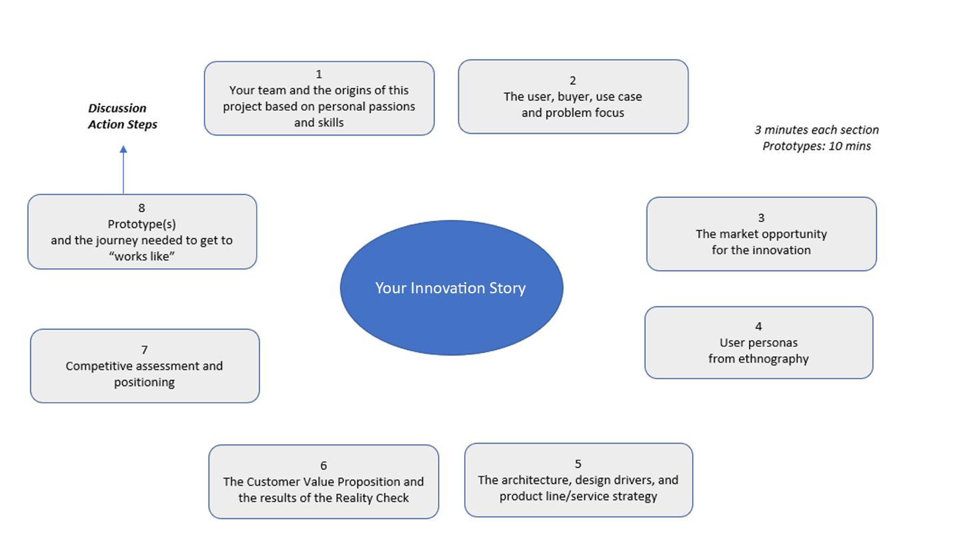

Assemble the templates from all your work above – plus any others that you found particularly meaningful – and from these, create your team’s innovation pitch. Do not just regurgitate the templates in your pitch; rather, take the key points from them to create your own, unique presentation. The templates help you think – but most are too complex to present to outside people who have not taken the course. Therefore, design this pitch as if you are presenting to a new set of investors.

Your instructor will provide specific templates as guideposts for your hand-ins, and may add her/his own templates to the instruction materials.

Don’t forget to add an attractive title page with your team members’ names and email addresses! You can also add an Appendix at the very back with particularly interesting information, such as industry data or the results of your customer interviews and Reality Check.

Individual Innovation Assignments

You will be required to submit two Reflection Journals, as well as a maximum two-paged double-spaced Synthesis, Integration, and Application paper by email at Week 4 and Week 14, respectively. Please note, this exercise is not about regurgitating the course concepts.

Personal Discovery Reflection Journal (15%)

At the beginning of this semester, you will have a time to think about yourself (who you are, what you are good at, which areas you want to contribute to) using several templates. After that session, you will have a quiet moment to think about yourself, your career, and your happiness in your life. Please start a Personal Reflectional Journal that presents why you came to your initial project selection, your team, and how those decisions were reaffirmed or changed throughout the semester.

Please write several a paragraph or two on each of the following topics:

- How would you assess your teamwork? What worked best for your team? What did not work so well?

- What, if anything, would you like to pursue as the next step as a result of this course. Would like to pursue the innovation idea further? This might mean taking additional courses in design or entrepreneurship, pursuing certain work internships in the target industry of your project, or even starting an actual company. How has the innovation journey in this course impacted your own personal discovery about your career path?

- How has the course, and its methods, made you feel about tackling societies problems through the combination of human-centered design and technology? Which projects other than yours did you find most inspiring?

