Included and Set Up to Succeed: An Evidence-Based Approach for Teaching Experiments in the Diverse Classroom

Student researchers: Matthew Andrachek, Evelyn Arana, Maya Changaran Kumarath, Maria Dominguez, Daniela Foster, Margaret Garcia, Maximus Gomez, Toni Gonzalez, Maria Guerrero, Brianna Osorio, Ailyn Palancares, Jeffre Perez Hernandez, Shaheen Rahim, Jorge Rodriguez-Mota, Jennifer Salinger, Lindsey Sanchez, Hargun Sethi, Azul Torres Vargas, Santiago Vazquez Garcia, Nathalie Yol-Aldana.

Experiment 1: Changing Clothes, Changing Minds: Attire Affects Support for Immigrants
Clothing can shape perceptions of an individual’s competence and identity (Brosky et al. 2003; Kwon 1994). We investigated how attire worn by Latino immigrants impacts perception and acceptance by others in the community. Can attire affect attitudes toward immigrants (or Latinos more generally)? We hypothesize that a Latino person in casual or stereotypical attire (i.e., “gangbanger” or “cholo” style) will receive less support than the same person presented in professional clothing. To test this hypothesis, we took two photos of a research team member: one photo in casual attire (flannel shirt, sneakers, bandana) and one in “professional” attire (suit, tie, glasses). Then, we randomly presented participants one of the two photos and asked, “How much do you support the person in the picture being in your community?” Respondents answered using a 7-point scale ranging from “very unsupportive” to “very supportive.”
Even with a predominantly liberal-leaning and Latino sample, we find significant support for our hypothesis. Although our sample expressed high levels of support across both images, clothing still matters. Participants were .29 points more likely to support the professionally dressed Latino in their community (97% significance). The strength of these findings lays the groundwork for further research on how attire shapes public opinion of immigrants, both in Latino-majority and -minority communities.

Figure 3. Clothes Treatment Images
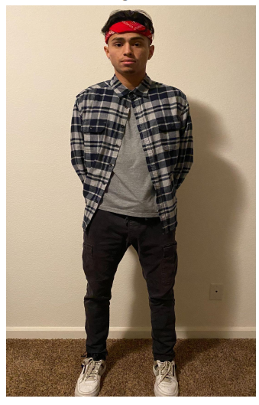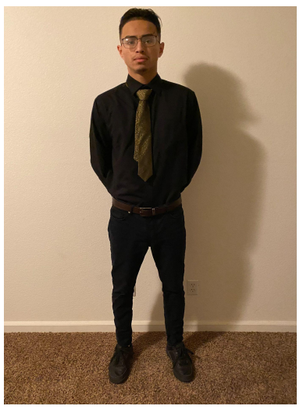

Figure 4. Experiment 1 Results
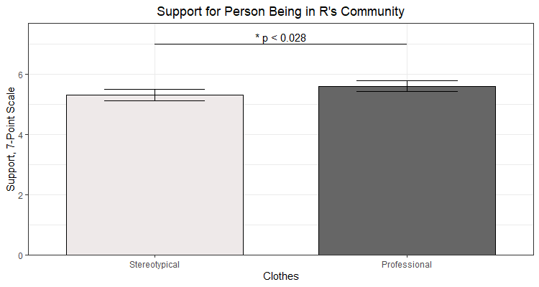

Experiment 2: We’ve Got Each Other’s Lungs (But Only If You Go First): An Experiment on Morality in an Age of Hyper-Polarization
To what extent does political partisanship affect moral decision-making? Recent scholarship identifies political ideology as a driver of moral intuitions (Hatemi, Crabtree, and Smith 2019), which can lead to dehumanizing members of political out-groups (Martherus et al. 2019). In a question-ordering experiment, we examine how positive interactions with the “political other” affect one’s own willingness to provide public goods that benefit one’s political out-group. We hypothesize that when one’s political out-group acts to help the respondent first, the respondent will be more willing to help that political out-group. We test this expectation by comparing people’s willingness to donate their lungs to a member of the out-party before and after they learn that the out-party member was willing to donate their lungs (to the respondent’s fictional daughter). Since our sample is overwhelmingly liberal, the fictional member of the out-party in these moral exercises is a QAnon Trump-supporter. We expect participants first asked to approve receipt of lungs from the out-partisan (thus priming knowledge of out-party public goods provision) will be more willing to donate their lungs to an out-partisan themselves.
We find a substantial treatment effect. Based on a 6-point scale, participants are .84 points more likely to approve of donating lungs to a QAnon Trump-supporter when their family is first offered a lung transplant from a QAnon Trump-supporter (99% significance). Our liberal-leaning sample was more willing to donate lungs to an out-partisan if they previously received a benefit from an out-partisan. Even as our sample was generally supportive of donating lungs in either condition, results suggest that people’s willingness to help members of the out-party depends in part on whether the out-party first signals a willingness to help them, too.

Figure 5. Experiment 2 Results
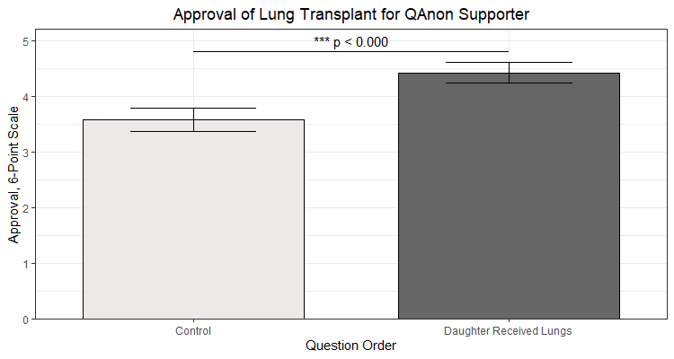

Experiment 3: How Gender Influences Evaluations of Black Candidates
Current research suggests women’s inclusion in government is hampered by public sentiment that men more naturally “belong” in politics (Carnevale 2019; Hall and Donaghue 2013; Aaldering et al. 2018; Bauer 2015). However, this literature traditionally focuses on white individuals (Huddy and Turkildsen 1993). Our study casts a different light by comparing candidates of color. We expect that implicit gender bias shapes perceptions of candidates’ experience and efficacy, with more favorable ratings for Black male versus Black female candidates. To test our expectation, we randomize participants’ exposure to an image of a fictional Black male or female political candidate in their 30s or 40s, with similar photo backgrounds and professional attire. Respondents were asked how many years of experience they believed that the candidate has, and expected vote share (as a proxy for viability).
In contrast to previous research comparing white candidates, we find that there is no significant difference in the expected vote share for the two candidates. At the same time, the Black female was perceived to have 0.9 more years of experience than the Black male (99% significance). While we are not sure why we observe this difference, the result touches on important political, social, and economic realities for Black Americans. While women of all major racial and ethnic groups pursue college at higher rates than men, until about 2000 the ratio of women’s degrees to men’s was higher for Blacks than whites. The percentage of Black women with degrees remains 6 points higher than that of Black men (Ryan and Bauman 2016).
Our findings may reflect respondents’ assumption that women (especially Black women) have a higher probability of holding a college degree. The result may also be a biproduct of negative stereotypes about Black men and/or respondents’ knowledge of structural and resource barriers which impact Black men’s academic and professional outcomes (McDaniel et al. 2011; Ellis et al. 2018). Our study raises new questions about race and gender in evaluating political candidates. Do existing theories of gender stereotypes apply to candidates of color? How do gender stereotypes about experience and job qualifications interact with racial stereotypes?
Figure 6. Experiment 3 Results
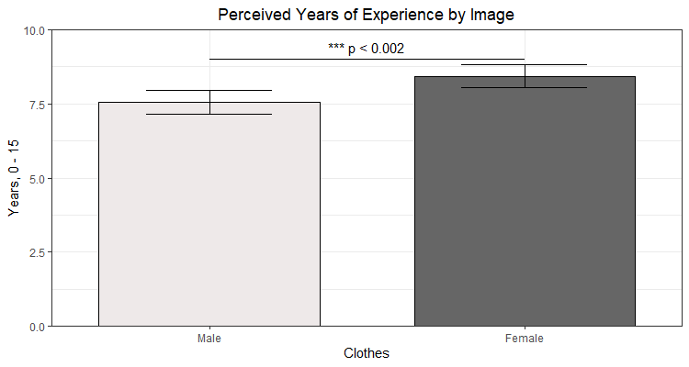

Experiment 4: Oh SNAP! Question Wording Shapes Support for Food Insecurity Programs
Though food assistance programs help millions of Americans out of poverty (Kreikemeier 2017), they often carry a negative public reputation (Mettler 2018; Chrisinger et al. 2008). In this study, we explore how negative perceptions of food assistance programs influence support for funding. We hypothesize that the term “SNAP” (acronym for the government’s Supplemental Nutrition Assistance Program) carries fewer negative connotations than “food stamps”, and we test whether terminology affects public support for funding. To do this, we design a survey experiment randomizing questions regarding “food stamps” or “SNAP.” We expect more support funding “SNAP” than “food stamps” due to “SNAP” evoking fewer negative connotations.
We find that choice of terminology significantly affects respondents’ support for food stamp funding. However, word choice works contrary to our expectations within our liberal student sample. On average, participants asked about “food stamps” were .24 points more likely than those asked about “SNAP” to agree these programs deserve more funding on a 7-point scale (95% significance). While unable to conclusively identify the mechanism in our study, we attribute this result to two factors. First, our pre-dominantly low-income sample may generally have favorable attitudes towards food assistance programs due to having direct exposure to beneficiaries of food stamps. Secondly (and relatedly), favorable attitudes toward food assistance may mean that using direct terms like “food stamps” evoke more support than acronyms or less obvious program names like SNAP. Overall, our research demonstrates how policymakers’ choice of what to call public assistance programs can affect public support for funding.

Figure 7. Experiment 4 Results
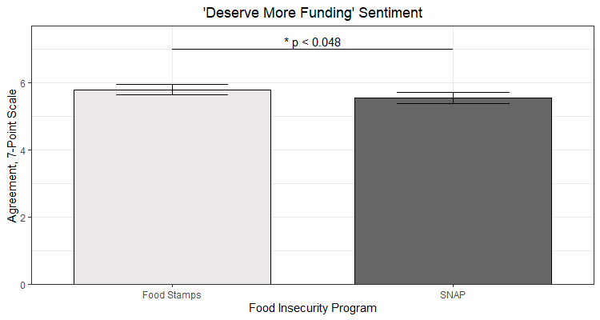

Works Cited

Aaldering, L., and Van Der Pas, D. J. (2018) ‘Political Leadership in the Media: Gender
Bias in Leader Stereotypes during Campaign and Routine Times’, British Journal of
Political Science.

Bauer, Nichole M. (2015) ‘Emotional, sensitive, and unfit for office? Gender stereotype activation and
support female candidates’, Political Psychology, 36(6), pp.691-708.
Brosky, M. E., Keefer, O. A., Hodges, J. S., Pesun, I. J., & Cook, G. (2003) ‘Patient perceptions of professionalism in dentistry’, Journal of Dental Education, 67(8), pp.909-915.

Carnevale, A. P., Smith, A., Campbell, K. P. (2019) ‘May the Best Woman Win? Education and Bias Against Women in American Politics’, Georgetown University Center on Education and the Workforce, Access at:
https://repository.library.georgetown.edu/bitstream/handle/10822/1053748/Women_in_Po
litics.pdf

Chrisinger B.W., Kinsey, E.W., Pavlick, E., Callison-Burch, C. (2020) ‘SNAP judgments into the
digital age: Reporting on food stamps varies significantly with time, publication type, and
political leaning’, PLoS ONE 15(2).

Ellis, J. M., Rowley, L. L., Nellum, C. J., & Smith, C. D. (2018) ‘From alienation to efficacy: An examination of racial identity and racial academic stereotypes among Black male adolescents’, Urban Education, 53(7), pp.899-928.

Hall, L. J., & Donaghue, N. (2013) ‘‘Nice girls don't carry knives': Constructions of ambition in media coverage of Australia's first female prime minister’, British Journal of Social Psychology, 52(4), pp.631-647.

Hatemi, P. K., Crabtree, C., & Smith, K. B. (2019) ‘Ideology justifies morality: Political beliefs predict moral foundations’, American Journal of Political Science, 63(4), pp.788-806.

Huddy, Leonie, and Nayda Terkildsen. (1993) ‘Gender stereotypes and the perception of male and
female candidates’, American Journal of Political Science, pp.119-147.

Kreikemeier, J. (2017) ‘Raising awareness about SNAP and hunger.’ Bread for the World, Access at:
https://www.bread.org/blog/raising-awareness-about-snap-and-hunger.

Kwon, Y. H. (1994) ‘The influence of appropriateness of dress and gender on the self-perception of occupational attributes’, Clothing and Textiles Research Journal, 12(3), pp.33-39.

Martherus, J. L., Martinez, A. G., Piff, P. K., & Theodoridis, A. G. (2021) ‘Party animals? Extreme partisan polarization and dehumanization’, Political Behavior, 43(2), pp.517-540.

McDaniel, A., DiPrete, T. A., Buchmann, C., & Shwed, U. (2011) ‘The black gender gap in educational attainment: Historical trends and racial comparisons’, Demography, 48(3), pp.889-914.

Mettler, S. (2018) ‘The Government - Citizen Disconnect’ Russell Sage Foundation.

Ryan, C. L., Bauman, K. (2016) ‘Educational Attainment in the United States: 2015’, United States Census Bureau, Access at: https://www.census.gov/content/dam/Census/library/publications/2016/demo/p20-578.pdf

Questions randomized: 1) “Imagine your daughter is recently identified as needing a lung transplant due to cystic fibrosis. A QAnon-following Trump supporter has recently passed away in a car accident. Their lungs are a perfect match. How do you feel about your daughter getting the transplant?” 2) “Imagine you were recently in a car accident and passed away. You are identified as an organ donor. The next person on the transplant list is a QAnon-following Trump supporter. How do you feel about them getting the transplant?” Responses on 6-point scale (Strongly disapprove to Strongly approve).
“How many years of professional experience do you guess that this candidate has?” (0 – 15 year scale)
“Here’s a candidate running for public office. What percentage of the votes do you think they will get?” (0 – 100 scale)
This may partly be due to our sample consisting primarily of liberals that may hold more favorable attitudes towards women.
“Please state how much you agree or disagree with the following statement: Food insecurity programs such as [SNAP/food stamps] deserve more funding.” (7-point scale from “Strongly disagree” to “Strongly agree”)

