**Appendix 8.1: Information flows for all EU Member States[1]**

**8.5.1 Austria**

When the Austrian FIU receives an STR related to ML it will analyse it and – depending on the result of analysis – it will conduct a criminal investigation under the supervision of the competent public prosecutor or it will forward it to other departments or organizational units of the Federal police for investigation.[2] In most cases, the FIU conducts the investigation, but depending on its competence and on the territorial competence of the police, the FIU can forward the investigation to other units of the Federal criminal police or to the local police.[3] According to the FATF (2009), the Austrian FIU’s ML investigations are divided into three areas: ML through the use of offshore, ML through fraud, and ML related to, or associated with, former Member States of the USSR.[4]

The reception of an STR implies the beginning of a police or judicial investigation. When the reporting entities indicate that the STR is related to FT, the FIU immediately forwards it to the BVT (Austrian Federal Agency for State Protection and Counter-Terrorism). The BVT is a law enforcement authority, established within the Ministry of Interior, which is responsible for investigating cases related to FT that originate from an STR (and are thereby forwarded by the A-FIU) or from its own sources.[5] The BVT has nine regional departments and conducts its criminal investigation under the supervision of the PPO. According to FATF (2009c), the BVT regularly uses financial investigations with the purpose of understanding the structure of terrorist groups.[6]

**Figure 8.5: AML/CTF Information flows in Austria**

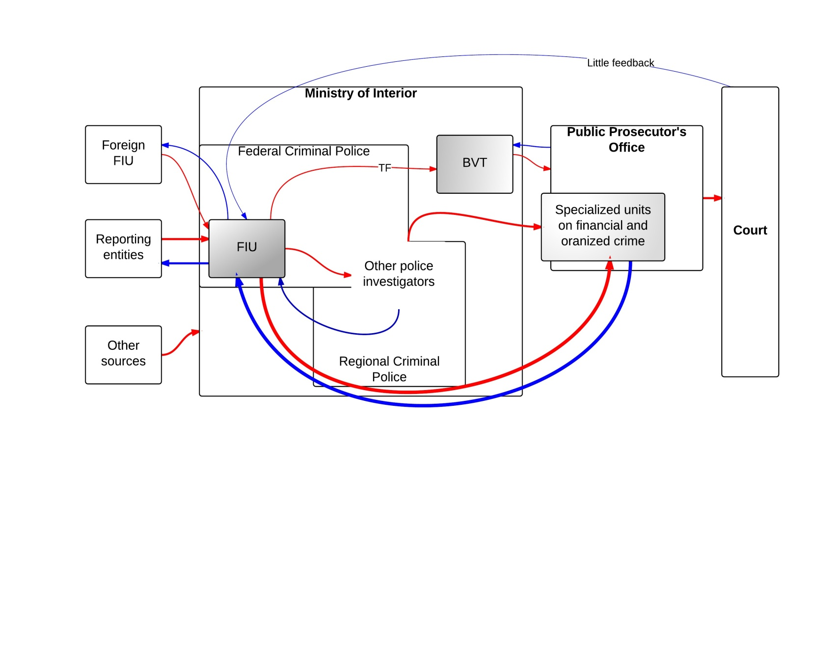

*Legend: In the figure above the red arrows show the ML/TF flows of information; blue arrows represent the feedback given and received by the FIU; the thickness of the arrows reflects the intensity of the information flows –in terms of both quantity and quality; shaded boxes are used to designate those departments/offices/institutions that have a higher level of speciali*zation in dealing with ML/TF cases.

Austrian law enforcement authorities must ensure that all ML and FT offences are properly investigated.[7] In Austria prosecutors prosecute ex officio all criminal acts which come to their knowledge and are not prosecuted only on demand of the victim or other interested parties. ML and FT are therefore prosecuted mandatorily.[8]

According to the Austrian representative, there are 17 prosecution offices competent to prosecute ML and TF. Competence is divided geographically and each prosecution authority is competent for a specific region. This is laid down in the Criminal Procedure Code. The PPO has a general responsibility to prosecute all criminal acts, including ML and FT. According to FATF (2009c), Austrian law ‘does not specifically provide for the establishment of special sections in charge of financial crimes and organised crime within the public prosecutor‘s office’. Nevertheless, according to the Austrian representative, there are groups of prosecutors in the larger prosecution offices in Austria which only deal with economic and organized crime, and Vienna has such a group of 10 specialized prosecutors. Furthermore, FATF (2009c) reports that out of 300 prosecutors operating in Austria, approximately 10% were specialized in ML and in investigating financial crimes.

According to the Austrian representative, during the investigation, the PPO and the FIU are in close contact and, once the prosecutor takes the case to court, the FIU receives feedback from the court when the case is dropped (when there is no conviction). The FIU does not receive feedback when the accused is sentenced unless they formally request this information. On the issue of ML, the Austrian representative argued that approximately 60% of indictments originate from the FIU reports and 40% from other police sources. Similarly, approximately 85% of convictions on ML can be traced back to FIU reports.

**8.5.2 Belgium**

When the Belgian FIU has declared that a specific STR or a ‘dossier’ is suspicious, the case is forwarded to the competent public prosecutor. Usually, this means the PPO where the transaction took place (geographical location). It is possible for the FIU intentionally to forward it to another district PPO if it has reason to believe that this will be more conducive to the success of the prosecution. However, in the latter case the FIU does not inform the prosecutor where the predicate offence and the laundering took place.

In Belgium, there exists no centralized database with all the information that the FIU has forwarded to the prosecuting authorities. This means that a prosecutor does not know whether other possibly relevant STRs have already been forwarded by the FIU to another PPO. Currently the issue is being addressed and the project ‘Gegevensdatabase’, whereby such a database will be constructed, is in progress.[9]

The FIU is well connected to the police and to the public prosecution’s offices. The FIU’s liaison officers provide access to police databases, but also take care of contacts between the FIU and the police. Also, the head of the FIU is a prosecutor detached to the FIU to ensure efficient flows of information to the prosecutors. Furthermore, since 2011 the FIU has had ‘contact magistrates’ for each district prosecution office.[10] These contacts are the entry points for information in the respective PPO. The contact magistrates have experience with financial crime but do not have to prosecute all the cases received from the FIU themselves. According to a Belgian representative, an increase in the financial and human resources allocated to the prosecuting authorities needs to be considered such that these can effectively process all the information delivered to them by the FIU.

**Figure 8.6: AML/CTF Information flows in Belgium**

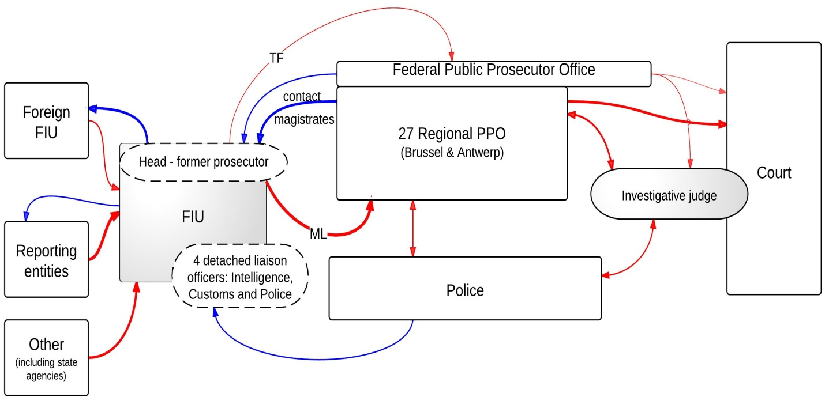

*Legend: In the figure above the red arrows show the ML/TF flows of information; blue arrows represent the feedback given and received by the FIU; the thickness of the arrows reflects the intensity of the information flows –in terms of both* *quantity and quality; shaded boxes are used to designate those departments/offices/institutions that have a higher level of speciali*z*ation in dealing with ML/TF cases.*

In Belgium the public prosecutor leads the criminal investigation. When the FIU forwards a case to the competent public prosecutor, the latter has essentially four options: to drop the case immediately; to forward the case to the police to investigate some more details (when additional evidence is necessary); to appoint an investigative judge who can, for a certain period of time, take the lead in the criminal investigation; or to prosecute the case immediately on the sole basis of FIU information. According to Belgian representatives, an investigation judge is generally involved when special investigative techniques need to be used, or when coercive measures need to be imposed. Investigations led by an investigative judge generally take longer (4 to 5 months). With respect to prosecutorial specialization, the federal prosecutor in Belgium is (mainly) responsible for taking up terrorism and terrorist financing cases. Only seldom will it prosecute ML cases as ML is generally handled by local prosecutors. The federal prosecutor has nationwide competence to prosecute, whereas district prosecutors have local jurisdiction.

The FIU receives feedback from the public prosecutor or police when a case is terminated or brought before the court and a final judgment is given. This feedback is given annually, but on a case-specific basis. The information that the FIU supplies to the public prosecutor is used either as a starting point for a case (i.e. the information from the FIU itself can be sufficient reason for a public prosecutor to go to court), or as additional information in an ongoing law enforcement investigation. In judgments, the value of FIU reports on STRs is generally not mentioned. However, typologies or indicators have been mentioned in various judgments, for example the fact that a person was not economically active, but was in possession of expensive cars and houses which could not be explained.

**8.5.3 Bulgaria**

In Bulgaria, upon the receipt of an STR, the FIU performs a financial analysis and forwards its conclusions.[11] The Bulgarian authorities mentioned that the tax office also sends reports to the FIU for further investigation.

According to the FIU representatives, the FIU has disclosed a large proportion of the results of its analyses to the competent directorates of SANS for further checks with regard to potential money laundering. A significantly smaller number of disclosures have also been made in relation to suspected terrorist financing cases. FIU representatives stated that during 2008–12 almost half of the disclosures made by the FIU were sent to the special directorates of SANS. A large number of these disclosures were reportedly sent to the specialized directorates of the Ministry of Interior Affairs. Further, the FIU also sent information directly to the PPO when there was enough information to immediately undertake pre-trial investigation or prosecution.

These operative entities supplement the analysis of the FIU with non-financial information that positions the suspect in a possibly criminal environment. During the course of their analysis, these officers can request the assistance of the PPO. Finally, when a case contains sufficient information, the operative officers forward their case to the PPO and a criminal investigation is started. At this point, police investigators can begin a pre-trial investigation under the supervision of investigative magistrates.

**Figure 8.7: AML/CTF Information flows in Bulgaria**

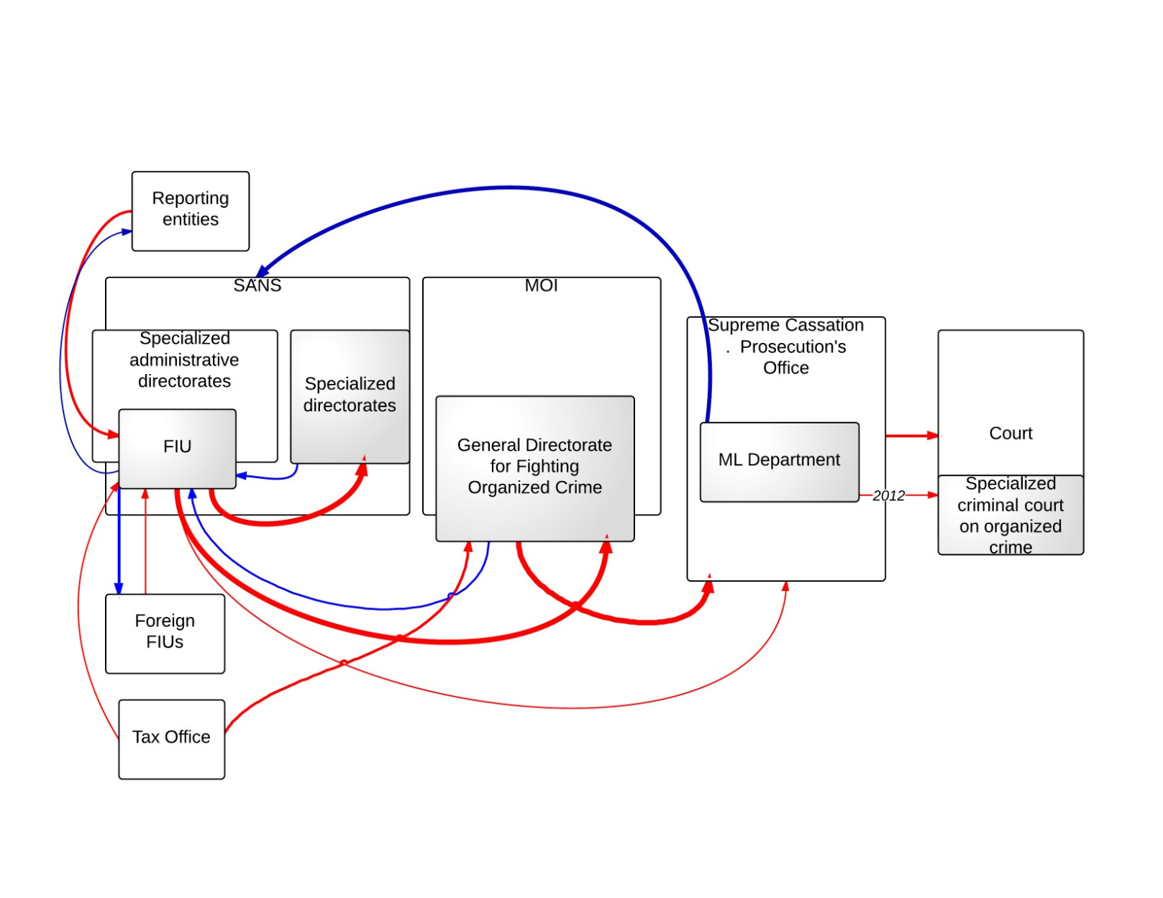

*Legend: In the figure above the red arrows show the ML/TF flows of information; blue arrows represent the feedback given and received by the FIU; the thickness of the arrows reflects the intensity of the information flows –in terms of both quantity and quality; shaded boxes are used to designate those departments/offices/institutions that have a higher level of specialization in dealing with ML/TF cases.*

The law enforcement entities are not obliged to automatically send feedback to the FIU with regard to the outcome (initiated pre-trial proceedings or prosecution) of the disclosures sent to them. However, the FIU authorities argue that the FIU receives feedback in other ways. Annually, the FIU receives approximately 300 requests from the competent law enforcement structures (including SANS, the Ministry of Interior and the prosecution services) for cross-checks with the FIU database. These requests are also taken into account when analysing future STRs. The interests of the law enforcement authorities are therefore incorporated into the future work of the FIU. In addition to this, the Bulgarian authorities argue that the LEAs usually revert back to the FIU after receiving a disclosure, in order to work on identifying further information on links or to ensure a proper financial analysis of the case and of the persons involved in the offence. Annually, the FIU seems to receive approximately 300 such inquiries.

Furthermore, the FIU representative mentions that, on the more important cases, cooperation between the FIU and the LEAs is very good. This is supported by the Bulgarian PPO representative, who argues that the PPO takes a serious view of assisting and giving feedback to the FIU and to the operative agents of the SANS and of the Ministry of Interior. This is due to the fact that the PPO recognizes the importance of the preventive investigations in what later constitutes the prosecution’s work. However, there is no requirement for the PPO to guide the FIU on this matter.

With respect to specialization, in Bulgaria, within the Supreme Cassation Prosecution’s Office there is a special AML department that deals with the most complex money laundering cases and, given the hierarchical structure of the Bulgarian prosecution system, is also in charge of giving support to district prosecution offices and magistrates dealing with money laundering cases. In 2012 a Specialized Criminal Court will be inaugurated where, according to the Bulgarian representatives, ML and TF cases will be able to be better investigated and tried.[12] There will also be a specialized PPO for organized crime that will investigate money laundering and terrorist financing.

**8.5.4 Cyprus**

In Cyprus, the head of the FIU is the first filter for the reports that reach the FIU. Based on the profile of the SAR, on the background of the investigators and on the number of cases that they are working on at the time, the head of the FIU decides on who will be the investigator of the SAR. The head can designate one or more investigators (a team) depending on the size of the case. The FIU performs the analysis of the STR and also the criminal investigation. All members of MOKAS have investigative powers; that is, they have the power to interrogate, take witness statements and travel abroad to receive information, and more. Further, the FIU usually cooperates with the other LEAs in Cyprus during their investigation.

**Figure 8.8: AML/CTF Information flows in Cyprus**

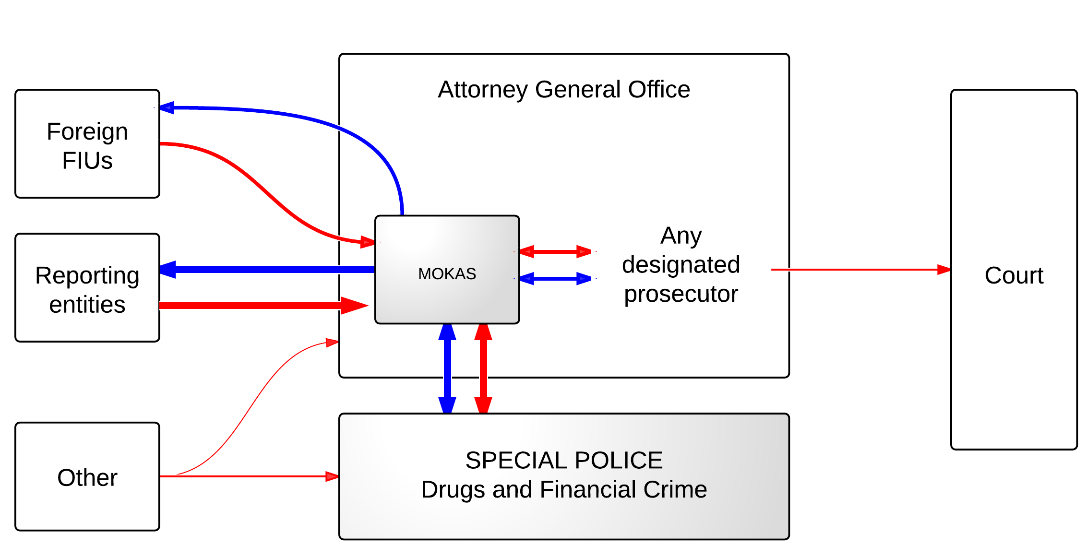

*Legend: In the figure above the red arrows show the ML/TF flows of information; blue arrows represent the feedback given and received by the FIU; the thickness of the arrows reflects the intensity of the information flows –in terms of both quantity and quality; shaded boxes are used to designate those departments/offices/institutions that have a higher level of specialization in dealing with ML/TF cases.*

The Cypriot representative argues that the FIU works closely with the police and in particular with the financial crime department and the drugs law enforcement department of the police. The FIU can and does request the assistance of these police officers in their investigations and to clarify whether some cases might be connected to drugs-related offences or not. Also, the police can request assistance in cases where the expertise of MOKAS might be useful.

When confronted with a case under police investigation which also involves money laundering, the investigation is prepared by the police and by their experts, while the FIU adds their investigation on money laundering to the police report. Further, the prosecutors of MOKAS offer legal assistance to their counterparts in the Attorney General’s Office (AGO) in cases involving money laundering and terrorist financing. They are also responsible for the confiscation of assets and goods once a conviction has been achieved.

With respect to feedback and specialization, the FIU seems to be the leading authority in AML/CTF matters, involved at all stages of preventive and repressive enforcement.

**8.5.5 Czech Republic**

If the Czech FIU (also known as the Financial Analytical Unit – FAU) finds facts suggesting that a crime has been committed, it shall lodge a criminal complaint under the Code of Criminal Procedure and provide the law enforcement authority with all the information that the Ministry has found in the course of its investigation.[13] The Czech representatives argue that this provision allows the law enforcement authorities better access to cases that are in the public interest. Moreover, the FAU reports suspicion without necessarily looking for evidence, given the administrative nature of the Czech FIU.[14]

According to MONEYVAL (2011), the FAU forwards its ‘criminal complaints’ to the Anti-Money Laundering Division of the Unit for Combating Corruption and Financial Crime (UCCFC) of the police, which investigates the cases. Moreover, since 2008 the FAU has sent almost the same number of reports to the tax administration for further investigation.[15] The FAU information is used to initiate a case. The report from the FAU is used as a starting point for a police investigation, and perhaps later during the investigation of the prosecutor. It is therefore not used as documentary information.

For every criminal complaint it filed, the FAU used to send a copy to the High Prosecutor’s office as well. This was meant to increase cooperation between the competent authorities and in particular to follow up the police force’s activity.[16] According to a Czech representative, this system has been changed and in 2012 the FAU also informs a responsible officer of the prosecutor’s office if it considers it appropriate in a given case.

**Figure 8.9: AML/CTF Information flows in the Czech Republic**

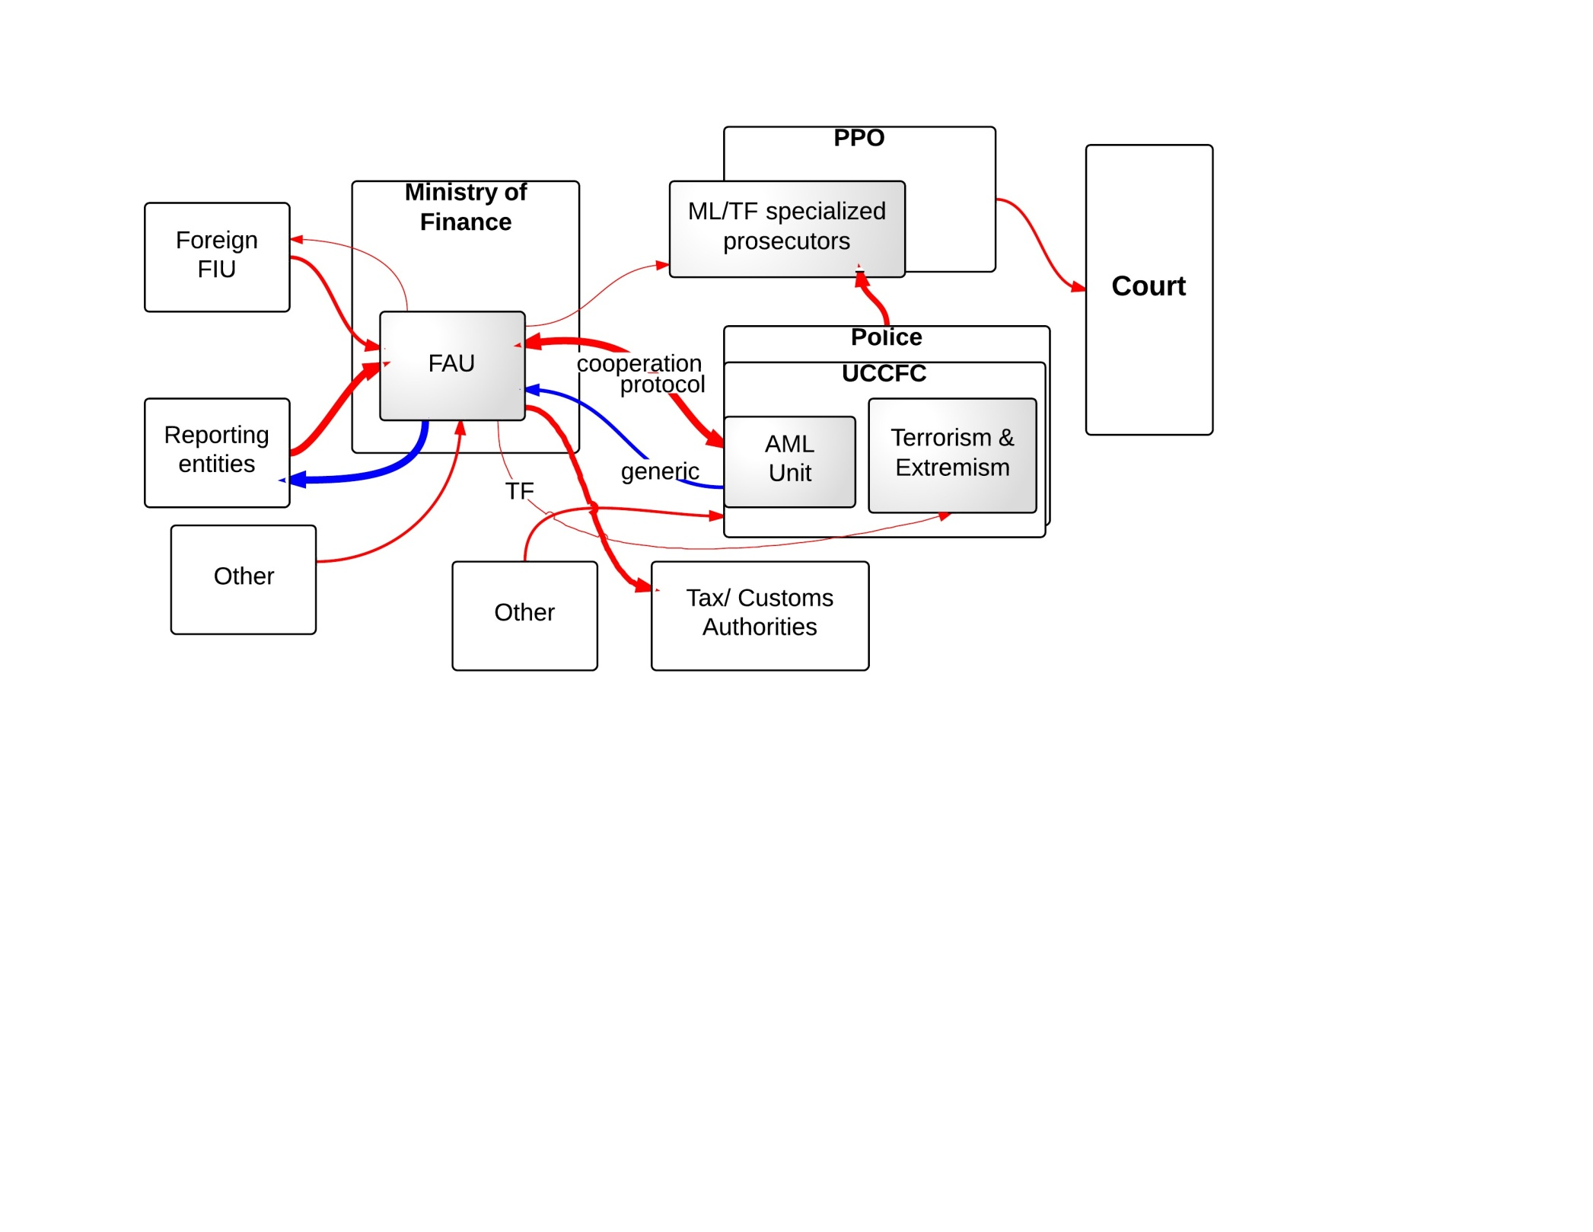

*Legend: In the figure above the red arrows show the ML/TF flows of information; blue arrows represent the feedback given and received by the FIU; the thickness of the arrows reflects the intensity of the information flows –in terms of both quantity and quality; shaded boxes are used to designate those departments/offices/institutions that have a higher level of specialization in dealing with ML/TF cases.*

According to MONEYVAL (2011c), the law enforcement authority designated to receive the criminal complaint from the FAU is the AML division of the UCCFC. The FAU also cooperates with the Organized Crime Unit of the Czech police, in particular with the specialist terrorism and extremism unit to which it forwards reports on terrorism finance. The UCCFC is responsible for investigations into ML, TF and other related crimes. The unit of 12 police officers is supervised by the High Public Prosecutor’s office. Within the UCCFC, there are a few specialized units – namely the Anti-Drug Unit and the Organized Crime Unit – which investigate the most complex ML cases. The less complex ML cases are investigated by regional specialists.[17]The Czech representative argued that the police forces handling the ML and TF investigations are professionals, but that they are too few to handle the work volume.

According to the Czech representative, the prosecution service has a centralized structure. There are four levels of prosecution – district, regional and national level and there are also specialized prosecutors who only deal with serious crimes – crimes that are of special interest in the EU context (i.e. serious corruption crimes, serious financial crimes). The most serious ML cases and the TF cases are prosecuted by these specialized prosecutors, whereas the less serious ML cases may also be prosecuted by lower-level prosecutors, even by district prosecutors. The system is constructed so as not to overload the specialized prosecutors and to allow them to concentrate their resources on the more complex cases.

The cooperation between the FAU and the AML division of the Czech police is regulated by a protocol signed by the Ministry of Finance and the Ministry of Interior. On the basis of this protocol, the FAU and the AML police can exchange intelligence and consult on individual cases. Furthermore, the FAU can obtain police intelligence that goes beyond criminal records – i.e. indictments, persons that have been or are under investigation.[18]

During the MONEYVAL visit in 2011, the current Director of the FAU came from the law enforcement side and was trying to enhance cooperation between the FAU and law enforcement. The quality of the reports of the FIU was reported by the Czech representatives. MONEYVAL (2011) also mentioned that the FAU has quite a proactive approach and provides the LEAs with more than a financial analysis.[19] MONEYVAL (2011) also points to the fact that the FAU often asks for assistance from the police and for additional information from the reporting entities and asks for little assistance from its foreign counterparts.[20]

According to the Czech representative, the FAU gets feedback from the police alone. MONEYVAL (2011) reports that the feedback the police give to the FAU is generic and does not help the FAU in performing its tasks.[21] Moreover, MONEYVAL (2011) argued that the ML reports were merged with the predicate offence investigation at a later stage, and pursued on the latter grounds. This made keeping accurate statistics difficult as well as de-motivating FAU staff.[22]

**8.5.6 Denmark**

In Denmark, the FIU will start an investigation upon receiving an STR. According to the Danish representative, if from the STR the FIU cannot directly see that a crime was committed, they forward the STR to the tax authorities, the FSA or the Danish Commerce and Companies Agency. Depending on the nature of the case and its complexity the FIU will forward a report to the Office of Prosecution for Serious Economic Crimes or to the police for further criminal investigation. The law enforcement agencies lead the pre-trial criminal investigation and only where the case turns out to be very complicated does a prosecutor lead the case.

**Figure 8.10: AML/CTF Information flows in Denmark**[23]

Supervised Entities

Anyone

FIU

PPO

Court

Police

Office of the Prosecution for Serious Economic Crime

Other institutions, like:

- FSA (5%)

- Tax Administration (10%)

feedback

*Legend: The blue arrows represent the information that flows from one agency to another (normally that is a report/case unless it is specified that it only concerns a copy) and the red dotted arrow illustrate supervision and case-specific feedback. We have only looked at feedback directed to the FIU, and therefore this figure excludes all other feedback, i.e. between court and prosecution.*

**8.5.7 Estonia**

In Estonia, the FIU forwards the information to the investigative bodies after a full analysis has been done on the report. The FIU decides which authority to forward it to. According to the Estonian representative, good cooperation and communication exist between the FIU and the prosecution’s office. The FIU receives feedback from both the PPO and police. There is a database in which the FIU can check for itself the status of a case. In every case, the PPO and/or police should inform the FIU when they open an investigation or decide not to follow up the report of the FIU.

**Figure 8.11: AML/CTF Information flows in Estonia**

Supervised Entities

Anyone

FIU

LEAs

PPO

Court

feedback

PPO decides which LEA investigates (filtering):

* **Police and Border Guard Board**
* **Police**
* **Tax &Customs**
* Others
* Security Police

*Legend: The blue arrows represent the information that flows from one agency to another (normally that is a report/case unless it is specified that it only concerns a copy) and the red dotted arrows illustrate supervision and case-specific feedback. We have only looked at feedback directed to the FIU, and therefore this figure excludes all other feedback, i.e. between court and prosecution.*

**8.5.8 Finland**

In Finland, the FIU sends the reports to the National Bureau of Investigation and to the local police. At the same time, a copy of the files is send to the prosecution’s office for consideration. According to the Finnish representative, the PPO is normally not involved and copies of the files forwarded by the FIU to the police are only handed over to the prosecution in cases of suspicion of terrorist financing. Furthermore, here the PPO has very little contact with the FIU, but this is also due to the limited role of the PPO in Finnish criminal law. This statement is confirmed by the Finnish prosecution representative.

**Figure 8.12: AML/CTF Information flows in Finland**

Supervised Entities

Anyone

FIU

PPO

Court

Security Police

or

Local Police

National Bureau of Investigation

a copy

feedback

*Legend: The blue arrows represent the information that flows from one agency to another (normally that is a report/case unless it is specified that it only concerns a copy) and the red dotted arrows illustrate supervision and case-specific feedback. We have only looked at feedback directed to the FIU, and therefore this figure excludes all other feedback, i.e. between court and prosecution.*

**8.5.9 France**

The FIU discourages an automatic declaration of STRs based on set principles – unless these are obvious. The reporting entities are encouraged to perform their own analysis on the complexity and the nature of the transaction and to report it to the FIU as long as there is a reasonable suspicion (based on their experience) that this could have an illegal foundation.

TRACFIN can initiate an investigation based on information received regularly from all sources (reporting entities, information provided by the courts, financial courts, state authorities, supervisory authorities or foreign FIUs). The prohibition of self-referral remains in the order of January 2009 – i.e. the service cannot work any longer on the basis of evidence brought to its attention by natural or legal persons who are not covered by Article L. 561-2.

Upon receipt, the FIU systematically tries to match the STR to information it has in its databases. If suspicion of ML/TF or any crime or offence under Article 40 of the Code of Criminal Procedure is maintained, the FIU will make an informative note, which will have to be signed by its director and finalized by the delegate magistrate that is assigned to work with the FIU, and thereafter forwarded to the law enforcement authorities.[24]

TRACFIN also has other legal opportunities for the distribution of financial information.[25] Transmissions to the customs administration, the judicial police, the tax administration and the intelligence services ensure that, in the absence of a reasonable body of evidence to support the presumption of a criminal offence, investigations by TRACFIN nevertheless reveal information that is most likely exploitable by these services. The financial information provided by TRACFIN to these authorities is not the same as that sent to the prosecutor. In this sense it is a less documented information note.

If the analysis of the FIU reveals that there is suspicion of tax evasion, the FIU shall notify the Directorate General of Public Finances (DGFIP), who thereafter, according to Section 1741 of the Tax Code, is allowed to use this information to perform its own duties. Moreover, when the DGFIP observes that there is ML with tax evasion as predicate crime, they will forward the information to the PPO. For more effective treatment of the STRs concerning fiscal fraud, TRACFIN has built up a hub of staff recruited from DGFIP that works within its premises and focuses only on these specific STRs.

In the cases related to TF, the FIU will notify the French Intelligence Services. This is done to ensure that information is spread rapidly for operational use. If the investigation by the Intelligence Services reveals a crime, then the Intelligence Services will notify the PPO.

On the matter of feedback, the order of 30 January 2009 requires the prosecutor to inform TRACFIN on the start-up of judicial proceedings, on non-follow-up, and on the decisions imposed by a criminal court, in cases where an information note from TRACFIN was employed. During the interviews, the FIU representatives argued that, since a magistrate is delegated to the FIU, feedback is received through this magistrate. Furthermore this ensures that the information notes of the FIU can match the legal requirements in order to be effectively used in any consequent judicial procedures.

**Figure 8.13: AML/CTF Information flows in France**

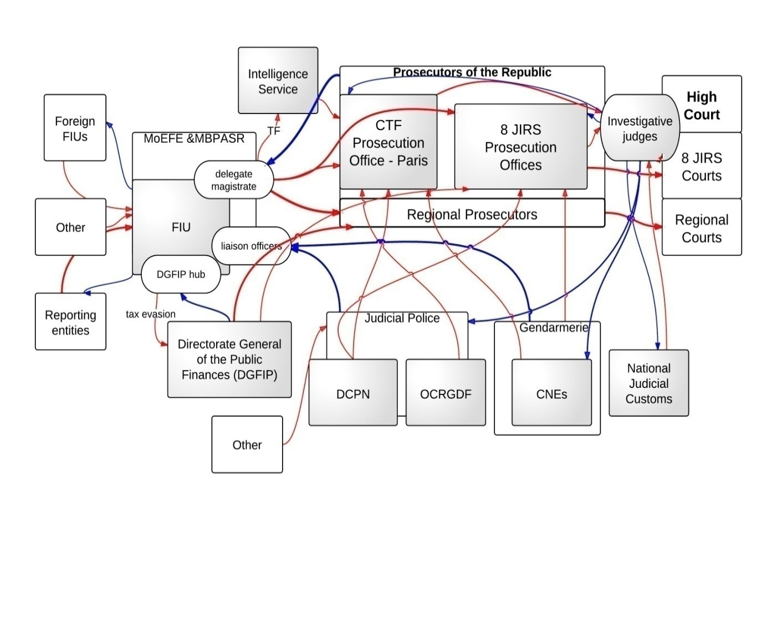

*Legend: In the figure above the red arrows show the ML/TF flows of information; blue arrows represent the feedback given and received by the FIU; the thickness of the arrows reflects the intensity of the information flows –in terms of both quantity and quality; shaded boxes are used to designate those departments/offices/institutions that have a higher level of specialization in dealing with ML/TF cases.*

*Specialized investigative authorities*

The Directorate General of the Judicial Police (DCPN) has two central offices that have national competence and are investigating ML: The Central Office for the Repression of the Major Financial Crimes (OCRGDF) – which handles money laundering, scams and serious fraud – and the National Financial Investigation Division – with expertise in corporate criminal law, public procurement and corruption. The OCRGDF centralizes and analyses the information it receives from the regional police, from the gendarmerie and the Customs, and coordinates their actions. The OCRGDF translates this information into operational and strategic data relevant to criminal investigations conducted both nationally and internationally.

Within the police headquarters in Paris there are also specialized services in economic and financial matters, i.e. the Financial Guard (competent in criminal law cases), the brigade fighting economic crime (competence in investigating corruption and public procurement), and the Research and Financial Investigations brigade (competent at investigating counterfeiting and money laundering).

As part of the most serious cases, the Gendarmerie occasionally puts in place national investigation teams (CNEs). These teams are particular to the Gendarmerie and bring together, on the same case, investigators belonging to different research units.

The National Judicial Customs (SNDJ) has jurisdiction[26] to investigate and detect crimes of money laundering.[27] The judicial customs officers are authorized to conduct criminal investigations on the request of the prosecutor or commission of the investigating judge over the whole national territory.

*Specialized prosecution and courts*

The only prosecuting authority in France is the Procureur de la République. The division of competence among the prosecutors is based on the court to which the prosecutor is appointed (High Court, Appeal Court, Inter-regional Specialized Jurisdiction etc.). The ML competence is based on geographical criteria – i.e. where the offence is committed, where the criminal lives or where the victim lives. There is only one exception – for the TF offence and its preparatory and/or ancillary offences, the prosecutor from the anti-terrorism section of the Court of Paris has national competence.[28]

A special feature of the French legal system’s fight against economic and financial crime is the superposition of several levels of competence. Within the judiciary, Paris holds a special place. This is due to the financial importance of this hub within the French economy. Furthermore, in France, there is a hierarchy of courts and prosecutors attached to them. France has created eight specialized interregional courts (JIRS) in economic and financial matters. These eight courts are competent to deal with complex cases. The JIRS are located in the largest economic centres of France (Paris, Bordeaux, Lille, Marseille, Nancy, Fort-de-France, Rennes and Lyon).

*Investigative judge*

In France, an investigative judge is a magistrate who conducts effective criminal investigations. He/she may not take up office and may not carry out investigation unless referred to by the PPO. The investigative judge is the investigator who has the most powers in France. He/she can hear any witness, summon witnesses through the police, issue warrants, hear plaintiffs and accused, appoint experts, conduct searches and seizures, order wiretaps, etc. The investigative judge conducts his/her investigation in consultation with the prosecutor and police or forensic teams, and appraises the applications for acts of the defence counsel or the prosecution. If the investigation leads to sufficient charges on some counts of prosecution, the investigative judge makes an order for referral to the criminal courts. Otherwise, he/she will make an order of dismissal.

The investigative judge is also a sitting judge. He/she can impose measures which are judicial, and that no investigator can impose. The judge may for instance indict a person but since 2001, he/she cannot imprison. The investigative judge is a specificity of the French legal system. Despite this, the role attributed to the investigative judge has been constantly reduced, and currently only 5% of cases are directed by the investigative judge. Nevertheless, these are some of the most complicated cases. Despite several discussions on the abolition of this position, the independent[29] nature of the investigative judge makes him/her an integral and necessary part of the French legal system.

**8.5.10 Germany**

In Germany, the Federal criminal police work in partnership with the police forces of the federation and the states and coordinate crime fighting at national and international level. According to the German representatives, the state police units are responsible for repressive enforcement within the state’s jurisdiction and can conduct ML and TF investigations under the direction of the prosecution.

Article 11 of the AML Act states that, regardless of the amount involved, ‘institutions and persons covered by the Act who have reason to believe that an offence under Section 261 of the Criminal Code or that terrorist financing has been or will be committed or attempted shall immediately inform the competent law enforcement agency orally, in writing or via electronic data transmission, with a copy to the Federal Criminal Police Office – Financial Intelligence Unit’. According to FATF (2010e), the Land police offices are the primary recipients of STRs in 14 states, whereas the PPO is the primary recipient in Hesse and Bavaria. If a transaction involves two or more states, the reporting entities inform the LEAs of the two states as well as the FIU.[30]

**Figure 8.14: AML/CTF Information flows in Germany**

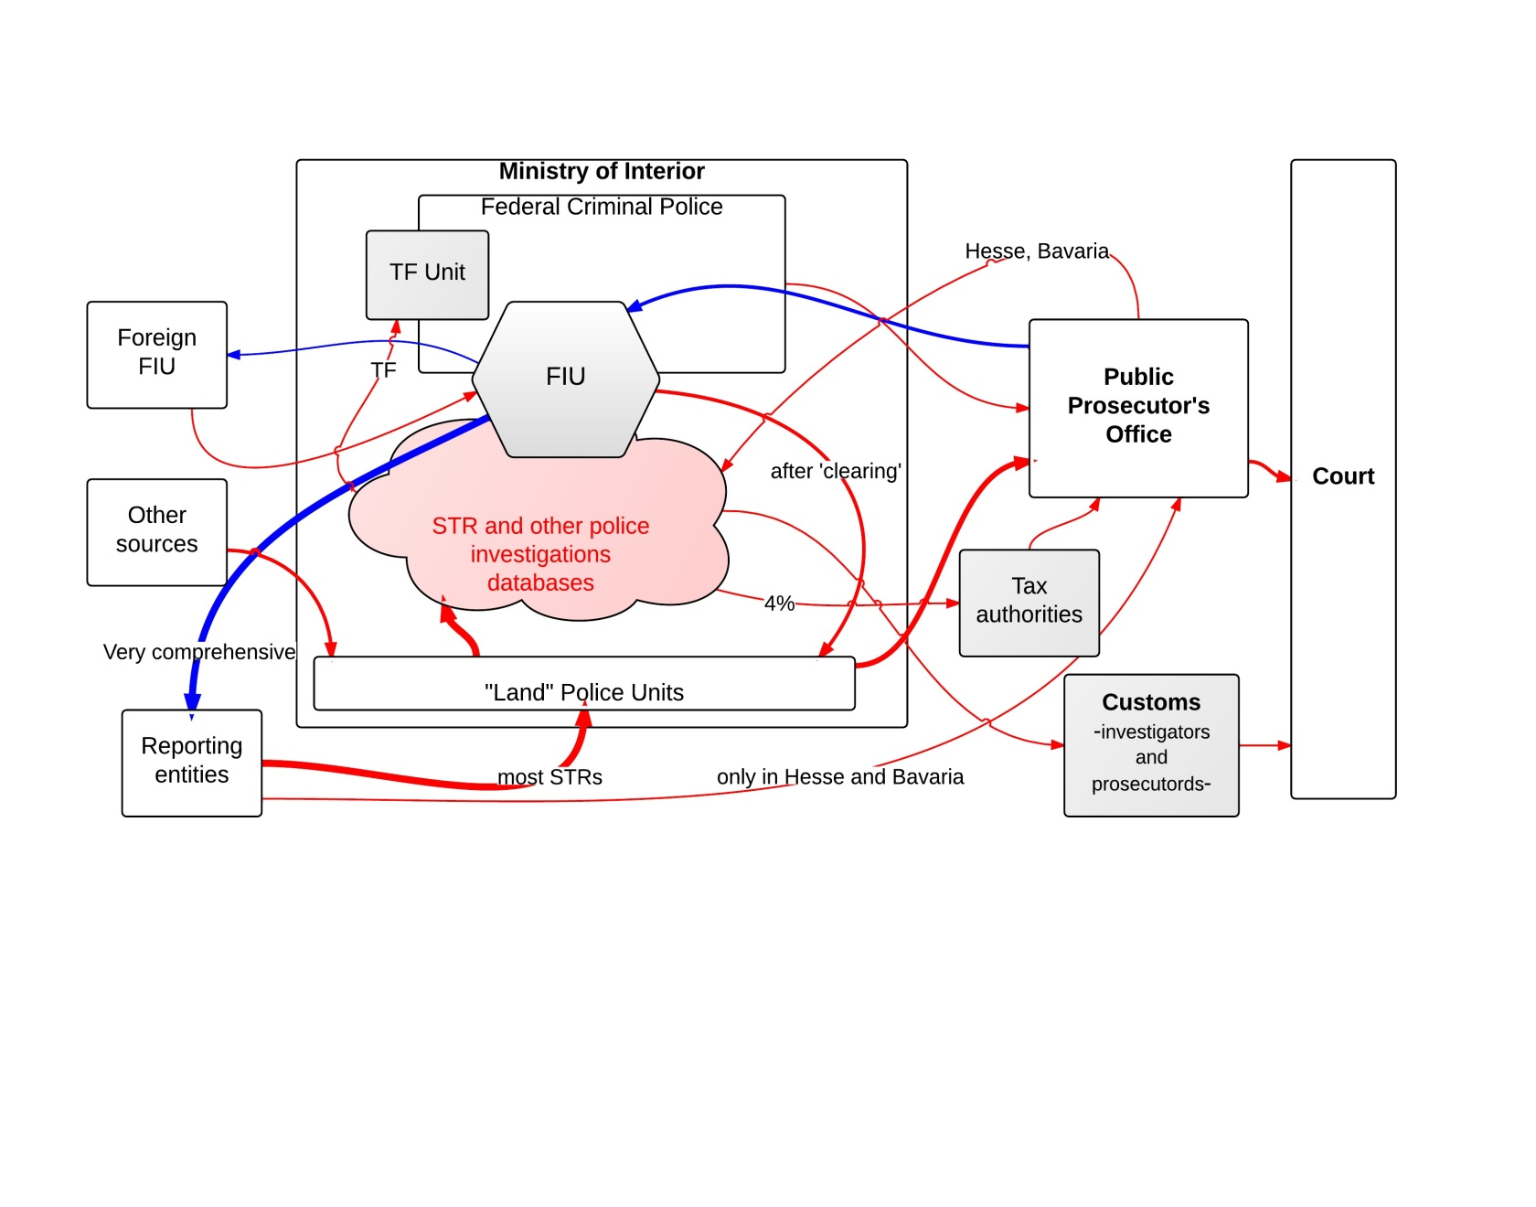

*Legend: In the figure above the red arrows show the ML/TF flows of information; blue arrows represent the feedback given and received by the FIU; the thickness of the arrows reflects the intensity of the information flows –in terms of both quantity and quality; shaded boxes are used to designate those departments/offices/institutions that have a higher level of specialization in dealing with ML/TF cases. Pink clouds designate the ML/TF database simultaneously available to multiple agencies (law enforcement and FIU) that is commonly used as the departure point for ML/TF criminal investigations.*

In Germany confirming and elaborating suspicions of ML or terrorism financing, and determining whether a report should be disseminated to law enforcement bodies for investigation and prosecution, is done in collaboration (FIU and LEA). This is because of the more elaborate data access system that the federal and the state police units have. Once the STRs have reached the local LEAs, the latter add the newly acquired information to the STR database, and here data-mining systems cross-check it with other available intelligence. The FIU can cross-check the information with other national and international databases[31] and, if a match is found, the FIU can coordinate the work of the criminal police who will investigate further.[32] Furthermore, the FIU’s expertise can be used for evidential purposes: the FIU has to ‘provide identification reports and forensic expert opinions for penal proceedings’ if requested by police services, public prosecutor’s offices and courts.[33]

The first analysis of the STR is called the ‘clearing process’ and, depending on the outcome, the intelligence will be forwarded to one or more state police units under the supervision of the local PPO, to the customs investigation offices, to the BKA (when it concerns TF) or to the tax administration.

According to FATF (2010e), as soon as an STR may be important for the tax authorities in initiating or conducting tax assessment or tax-related criminal proceedings, the FIU shall notify them. The FIU also forwards all TF-related STRs to the specialized Terrorist Financing Unit of the BKA. Furthermore, to avoid delays, the FIU database is also available to three TF investigators.[34] According to FATF (2010e), customs investigation officers are investigating officers of the PPO and have the same rights and duties as police officers. They are the competent criminal prosecution officers when investigating and prosecuting ‘internationally-organised ML and related criminal offences to the extent that these are connected to the movement of goods from and to external territories’.

According to Article 11 of the AML Act, the competent PPO shall inform the FIU of the commencement of public legal proceedings and of the outcome of the proceedings, in cases where a criminal investigation was started from an FIU report or where ML was collaterally investigated. This shall take the form of sending a copy of the indictment, the reason for dismissal or the verdict.[35] However, feedback only rarely contains explanatory information or information of typological relevance. According to the FIU Annual Report, it was often not possible to establish if the proceedings were dropped in relation to suspicion of money laundering, but continued in relation to the predicate offence.

**8.5.11 Greece**

The Greek FIU receives information from the reporting entities and from other national agencies via the AML/CTF/SFI Authority. The Chairman decides which of the three units will handle the report and therefore these flows of information are mediated, because in effect the Chairman can determine the course of the information flows and whether they reach the FIU or not. With respect to Foreign FIUs the information is no longer filtered as it naturally has reached the best institution to handle it. After receiving an STR the FIU investigates and the case is either archived or transmitted to the competent PPO. According to the FIU representatives, the Greek FIU compiles very good reports of analysis for the PPO and this is confirmed by the fact that the PPO rarely returns to the FIU for more information and by the fact that almost all of the reports which are passed on to the PPO are prosecuted further.[36] Depending on the nature of the case, it will be investigated by a first instance PPO or by higher-level PPOs. Accordingly, it can be investigated by the newly formed Specialized Financial Crime prosecution offices.[37] Investigative judges can be employed in the investigation of more complicated cases.

**Figure 8.15: AML/CTF information flows in Greece**

*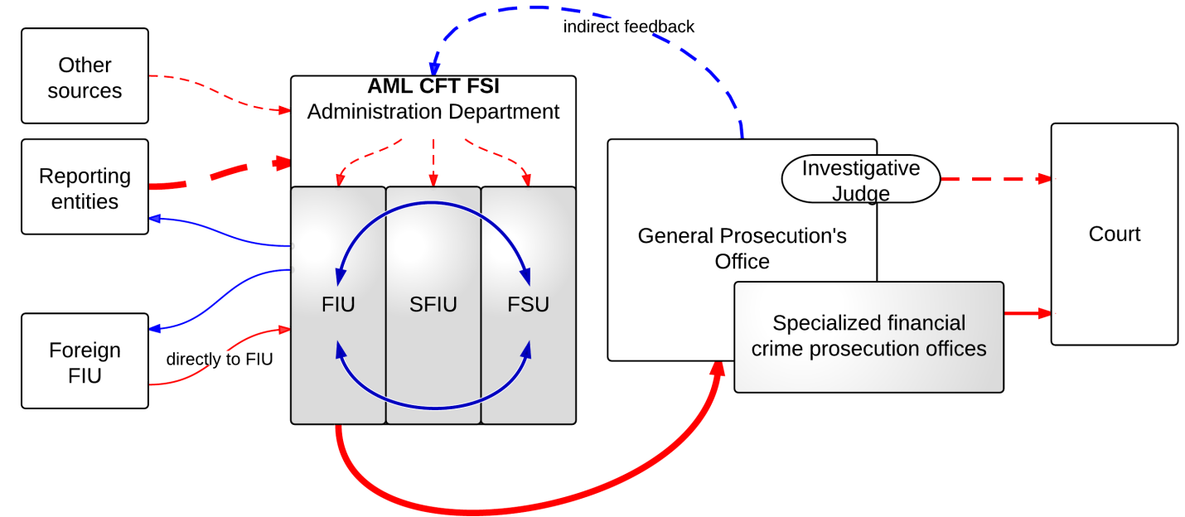Legend: In the figure above the red arrows show the ML/TF flows of information; blue arrows represent the feedback given and received by the FIU; dotted arrows mark intermediated flows (feedback); the thickness of the arrows reflects the intensity of the information flows – in terms of both quantity and quality; shaded boxes are used to designate those departments/offices/institutions that have a higher level of specialization in dealing with ML/TF cases.*

With respect to feedback, the FIU receives its feedback from the PPO mostly – but this is an intermediated flow of information. The head of the Authority, being an active Prosecutor, remains informed of the developments of the cases started by the FIU as well as on the possible shortcomings of the investigation; hence in terms of feedback the FIU agents receive direct feedback from their head. According to the Greek representatives, the new structure of the FIU ensures that every member of the staff learns from his/her colleagues. The feedback flows in the Greek case could best be described as diffuse and centred at the melting pot that is the Authority.

With respect to specialization, the highest degree of specialization could be seen within the Authority and the Financial Crimes Prosecution Services. With respect to the AML/CTF/SFI Authority, it is doubtful whether employing staff by detachment for short periods of time could ensure the degree of specialization that persistence and consistency usually ensure. Given the novelty of this organization, it is impossible to investigate these considerations further.

Having described the Cypriot model previously, one can see the scope of the similarities between the two. The new Greek FIU has been designed with a clear look at the Cypriot MOKAS. The rest of the information flow dissimilarities between the information flow charts are therefore due to the different legal systems of the two countries.

**8.5.12 Hungary**

The Hungarian FIU is an independent directorate within the Criminal Directorate General of the National Tax and Customs Administration (NTCA), as a result of a merger between the Hungarian tax and customs. Information on TF can also surface from the National Security Office – the Hungarian specialized intelligence agency that monitors persons capable of threatening the financial and economic security of Hungary.[38]

Upon receiving a report, the HFIU initiates an administrative investigation. The HFIU can disseminate financial information obtained under the AML/CTF Act to other investigating authorities – i.e. the public prosecutor, the national security service or an authority operating as a foreign FIU.[39] Furthermore, the information disseminated by the HFIU can be used in ML/TF investigations but also for the purpose of investigating tax fraud, embezzlement, fraud and misappropriation of funds. At the time of the MONEYVAL (2010) visit, issues were raised with regard to the limited decision capacity of the HFIU to decide to which LEA to disseminate information – when it deemed necessary. These concerns may have been addressed since.[40]

**Figure 8.16: AML/CTF Information flows in Hungary**

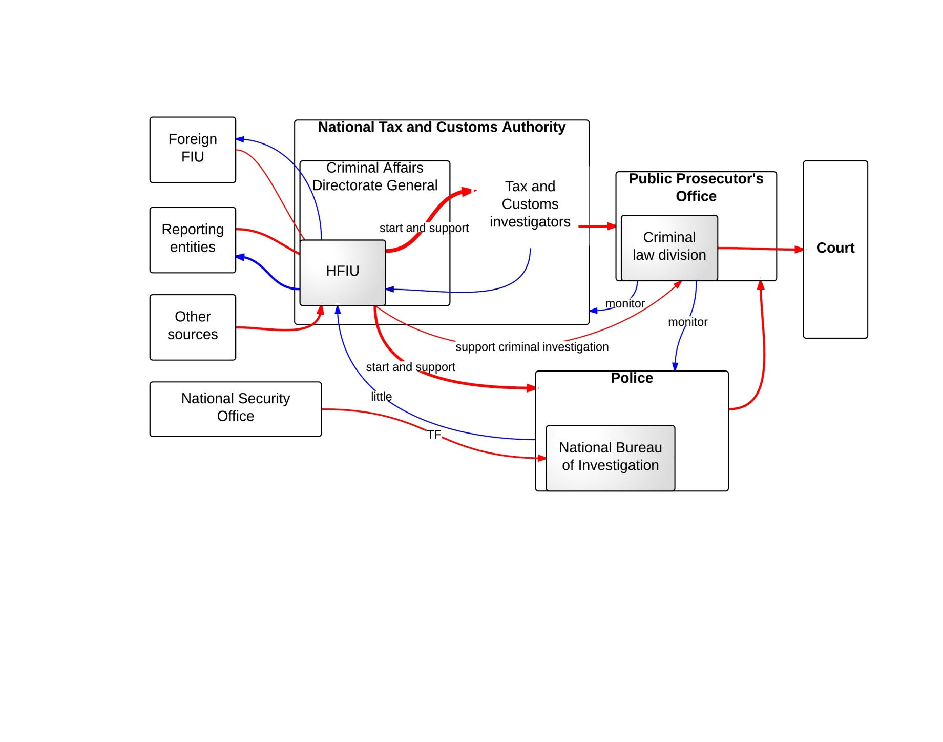

*Legend: In the figure above the red arrows show the ML/TF flows of information; blue arrows represent the feedback given and received by the FIU; the thickness of the arrows reflects the intensity of the information flows –in terms of both quantity and quality; shaded boxes are used to designate those departments/offices/institutions that have a higher level of specialization in dealing with ML/TF cases.*

The competence for money laundering is shared between the NTCA, the Prosecution Office for Criminal Investigation and the police. The NTCA holds primary competence and the police investigate cases of ML where investigations were originally started on other crimes. When ML is committed by persons with legal immunity or by persons with international legal status, members of the court or of the prosecution, notaries or any other law enforcement authority, the investigation falls under the competence of the Prosecutorial Office for Criminal Investigations.[41] Furthermore, cases of terrorism financing are handled by the National Bureau of Investigation.[42]

The investigating authorities can coordinate their actions as long as the heads of the investigation authorities and the prosecution admit the need and agree to such coordination.[43] MONEYVAL (2010c), however, notes that until 2010 such joint task forces had not been registered in money laundering investigations.[44]

After this criminal investigation, it can be decided to forward the case to the PPO. It seems therefore that there is no direct connection between the FIU and PPO. Moreover, the HFIU is reported to lack feedback from law enforcement authorities regarding the STRs disseminated either for supporting ongoing investigations, for initiating covert investigation or for supporting covert investigation. MONEYVAL (2010c) noted that such statistics were not gathered on a regular basis.[45]

The prosecution service is headed by the General Prosecutor’s Office and is organized on a geographical basis into regional appellate prosecutors, county prosecutors and local prosecutors. Of particular interest is that within the General Prosecutor’s Office, there exists a criminal law division which includes amongst others a department for the supervision of investigations and a department for special cases. According to MONEYVAL (2010c), this separtment was set up on 1 July 2001 and is supervised by the Deputy Prosecutor General. The department is allowed to monitor special cases of interest – among them money laundering and terrorism financing cases. The county prosecution offices have an office for criminal investigations, a division for supervising investigations and a division for court proceedings. It is however unclear whether these prosecutorial structures are specialized prosecutorial structures that handle cases of money laundering and terrorism financing. MONEYVAL reports that in 2010 approximately 8% of the Hungarian prosecutors dealt with economic crimes.[46] Furthermore, courts and prosecutors are reported to have had extensive training in money laundering techniques but that further training is needed.[47]

**8.5.13 Ireland**

In Ireland the 2010Act stipulates that STRs must be submitted to both the FIU and the Revenue Commissioners. Both authorities receive STRs at the same time. The Revenue Commissioners take a special interest in tax evasion matters, and view STRs from this perspective. If it is believed that proceeds can be confiscated in a civil litigation, the Revenue Commissioners will take action. About 95% of the STRs are dealt with from a civil perspective. Both the FIU and the Revenue Commissioners have an STR database. Furthermore, the Irish representatives mention the existence of a Memorandum of Understanding between the Revenue Commissioners and the UK’s HMRC for the exchange of STR information. This is said to be a unique construction.

The FIU and the Revenue Commissioners meet every six to eight weeks to discuss which STRs will be picked up by the FIU and which can be passed to the Revenue Commissioners. In principle the FIU takes the lead in deciding whether it will proceed with an STR or whether it should be passed to the Revenue Commissioners. However, the contrary also happens: if the Revenue Commissioners think that an STR contains information that the police should further investigate, the STR is passed on to the FIU. Hence, in the early stages the FIU and the Revenue Commissioners work together to make sure that there is no overlap in the analysis and actions taken on the basis of an STR.

The FIU in Ireland is a small subsection of An Garda Síochána, the Irish police force. The FIU falls under the National Support Services, under the Bureau of Fraud Investigations, and works in close contact with two police investigative units that also fall under An Garda Síochána. Once the FIU receives an STR, it will conduct a preliminary analysis and, depending on the nature of the case, it will forward it to the most appropriate investigative units within the An Garda Síochána. The advantage of a small police force, according to the Irish representatives, is that there is less bureaucracy. Furthermore, this means that the FIU receives good feedback from the investigative authorities to which it forwards its cases.

The An Garda Síochána does the investigation independently of the Office of the Director of Public Prosecutions (DPP). The DPP is involved as advisors at the request of the police. The latter however is not standard. The ‘regular’ procedure, according to the Irish representatives, is that the An Garda Síochána first performs its criminal investigation, after which the case file is sent to the DPP. The DPP decides thereafter whether to prosecute or not.

**Figure 8.17: AML/CTF Information flows in Ireland**

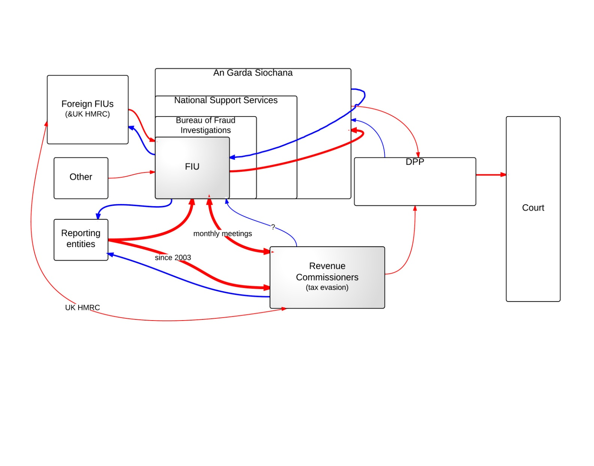

*Legend: In the figure above the red arrows show the ML/TF flows of information; blue arrows represent the feedback given and received by the FIU; the thickness of the arrows reflects the intensity of the information flows –in terms of both quantity and quality; shaded boxes are used to designate those departments/offices/institutions that have a higher level of specialization in dealing with ML/TF cases*.

The Irish prosecution system has strong common law origins that have given it its current shape. Historically, before the 18th century criminal prosecution in Ireland was brought by individuals in a similar way to civil actions. The victim therefore was most likely the prosecutor. In the course of the 20th century statutes were created by the Irish legislator to solely empower the Office of the District Public Prosecutions with the prosecution of indictments – i.e. trials before a judge and jury. Accordingly the notion of independent and permanent prosecutors was born.

Finally, as a result of this late development of the prosecution system and as a consequence of the still present mixture of common law and statute law, in Ireland there currently exists a broad spectrum of public and private prosecutors that act independently of each other, and there is a large degree of separation between the investigation, prosecution and trial stages of a criminal process.[48]

A number of public authorities with statutory competence are empowered to independently initiate prosecutions and in practice many of them do so. However, no trial on indictment can proceed without the consent of the Director of Public Prosecutions. Private persons may in theory still initiate criminal prosecutions for summary offence trials; however, in practice this is unheard of in the modern era.

In Ireland there are summary and indictable offences, a distinction that corresponds to the continental distinction between crimes and misdemeanours. Summary offences are dealt with by a judge sitting without a jury, and are trialled in the district courts. Indictable offences should be tried before a judge and jury – i.e. in the circuit courts. Whether a crime is considered a summary offence or an indictable offence is a case-by-case decision, but the different prosecutors meet regularly to ensure that a consistent policy is maintained. The circuit court is usually the competent court in ML cases. Terrorist offences are tried and dealt with by a special criminal court before three judges (without a jury), which is exceptional.

Regulatory offences under the AML Act 2010 are ‘hybrid offences’, in that these can be summary or indictable offences. The penalty for indictable offences under the AML Act 2010 is set at five years, which means that arrest warrants may be used. Supervisory authorities observing ML/TF breaches are under a duty to report to the DPP. The DPP decides whether it is a summary or indictable offence. If it is an indictable offence, DPP takes up the prosecution. If it is a summary offence, then administrative sanctions can be imposed.

On the matter of ML/TF specialization, this is generally done by learning by doing, as the historical developments of the prosecution system in Ireland do not seem to have allowed for the formation of specialist prosecutors or of prosecutors responsible for particular crimes.

**8.5.14 Italy**

In Italy, the FIU analyses the STRs and then transmits them, together with a financial analysis, to a special task force of the Financial Police[49] and to the Bureau of Anti-mafia Investigation (DIA). The FIU does not make a choice as to the agency to which the STRs should be forwarded. The FIU can close an STR as irrelevant, pursuant to internal regulations and procedures. The Italian authorities argued that, in fact, all STRs received by FIU are transmitted to both the DIA and to the NSPV. Further, when the STR concerns organized crime, the National Anti-mafia Directorate is informed by these two agencies.[50]

**Figure 8.18: AML/CTF Information flows in Italy**

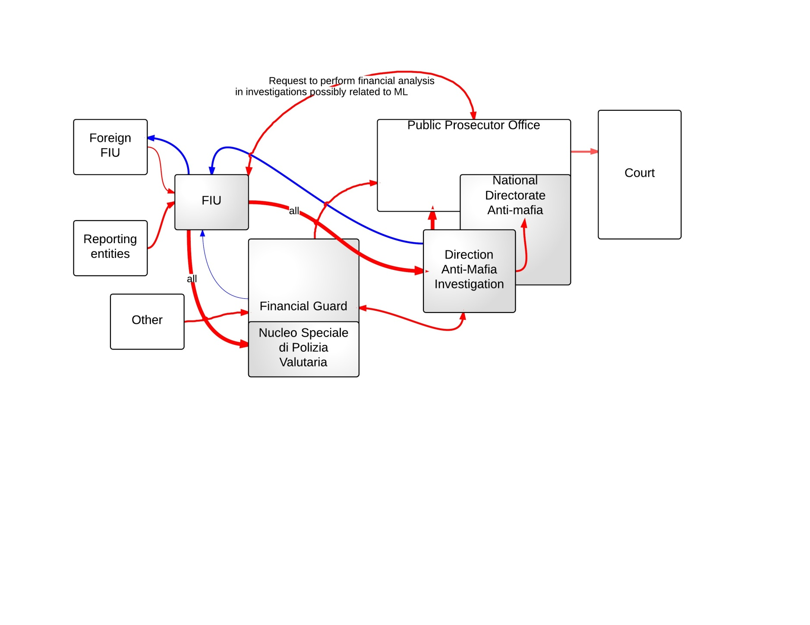

*Legend: In the figure above the red arrows show the ML/TF flows of information; blue arrows represent the feedback given and received by the FIU; the thickness of the arrows reflects the intensity of the information flows –in terms of both quantity and quality; shaded boxes are used to designate those departments/offices/institutions that have a higher level of specialization in dealing with ML/TF cases.*

Italy exhibits a wide array of specialized units handling the prevention and repression of AML/CTF cases. Special attention is given here to tax fraud and to mafia-related money laundering and terrorist financing investigations. The Financial Police is a law enforcement body specialized in preventing and repressing economic and financial crimes. The Anti-Mafia Investigative Directorate is a specific branch of the Department of Public Security within the Ministry of Home Affairs, with members from the state police, the financial police and the national police. The NSPV is a specialized body within the financial police dedicated to the investigation of STRs, following initial analysis and dissemination by the FIU. With respect to the prosecution service, there is a special prosecution body that handles Mafia-related cases – the National Directorate Anti-Mafia (NDA). Cases investigated by the DIA are supervised by the NDA and cases investigated by the GdF are supervised by the Nnational prosecution service.

According to the Italian authorities, the PPO usually requests information from the FIU in relation to other criminal investigations where there is additional suspicion of money laundering. In this sense, collaboration between the FIU and the PPO has increased as the flows of information between them have doubled in the past years.[51] However, the Italian authorities argued that the PPO does not provide feedback to the FIU on the relevance of the information it provided with respect to later stage prosecution. Furthermore, the FIU receives very little feedback from the LEAs on reports that have not been further investigated.

**8.5.15 Latvia**

In Latvia, the FIU on its own initiative can disseminate information to pre-trial investigation authorities and courts when it has reasonable suspicion that a criminal offence including ML and TF has been committed. According to the Latvian representative, the FIU forwards the STR and the FIU analysis to the police and a copy to the PPO. The PPO will supervise the actual criminal investigation but not give further feedback. The police give feedback to the FIU when they initiate a case. Upon receiving this feedback, the FIU informs the reporting entity that its report will be investigated by the police. According to the Latvian FIU, feedback is not useful for constructing typologies because the information needed for that is already available to this law enforcement FIU. The FIU needs the feedback for its own administration and to understand how useful the information provided to the police by the FIU actually was.

**Figure 8.19: AML/CTF Information flows in Latvia**

Supervised Entities

Anyone

FIU

LEAs

PPO

Court

PPO supervises the LEAs that receive reports:

* Economic Crime Police
* Organised Crime Police
* Financial Crime Police
* Security Police
* Anti-Corruption Bureau

a copy

*Legend: The blue arrows represent the information that flows from one agency to another (normally that is a report/case unless it is specified that it only concerns a copy) and the red dotted arrows illustrate supervision and case-specific feedback. We have only looked at feedback directed to the FIU, and therefore this figure excludes all other feedback, i.e. between court and prosecution.*

**8.5.16 Lithuania**

Upon completing a report, the Lithuanian FIU will forward it to the respective territorial FCIS unit which decides whether to start a criminal investigation or not. With respect to TF the cases are forwarded by the FCIS to the State Security Department. According to the Lithuanian representative, the FIU always requires feedback when a report is forwarded to the police or tax authority. The criminal investigation is under the control of the PPO, which is not assumed to give feedback.

**Figure 8.20: AML/CTF Information flows in Lithuania**

Supervised Entities

Anyone

FIU

PPO

County investigation units

State Security Department

Tax Inspectorate

FCIS

Court

feedback

*Legend: The blue arrows represent the information that flows from one agency to another (normally that is a report/case unless it is specified that it only concerns a copy) and the red dotted arrows illustrate supervision and case-specific feedback. We have only looked at feedback directed to the FIU, and therefore this figure excludes all other feedback, i.e. between court and prosecution.*

**8.5.17 Luxembourg**

The Prosecutor General (PG) oversees the Prosecutor’s office of Luxembourg (PL) and the Prosecutor’s office of Diekirch (PD). The latter two are district prosecutorial offices. Money laundering and terrorist financing can only be tried by prosecutors of the PL. They have national competence in the entire territory of Luxembourg. The FIU is located within the Economic Crime Department of the PL.

The FIU receives information from the reporting entities, from other FIUs, from other judicial authorities uncovering money laundering or terrorist financing in the course of their investigations, and from the state agencies (i.e. the secret service). The FIU provides feedback to all these institutions. FIU Luxembourg also employs a liaison officer to the judicial police. The liaison officer helps the FIU find out whether there is police intelligence related to their case in Luxembourg or internationally (via Interpol).

The FIU Luxembourg investigates an STR and conducts an intelligence analysis. It thereafter forwards the FIU analysis report to the competent prosecutor. At present, the FIU is not helped in its intelligence operations by any complex IT system. This problem is understood by the authorities and, according to the Luxembourg representative, a special team has been put in place to develop such an IT platform for the FIU such that they are able to undertake automatic analyses.

In Luxembourg, the prosecution can be conducted by the prosecution office or by the investigative judge. If the prosecutor decides that in the specific case coercive measures against the suspect must be used, the judicial dossier is forwarded to an investigative judge who will lead the financial investigation further. When an STR reveals information that could also lead to the prosecution of the predicate offence, the FIU can forward all of this information to the other prosecutors of the PL or PD. They will try to prosecute in parallel for the predicate offence. Similarly the other prosecutors will forward cases to the FIU where ML is revealed in the course of the investigation.

**Figure 8.21: AML/CTF Information flows in Luxembourg**

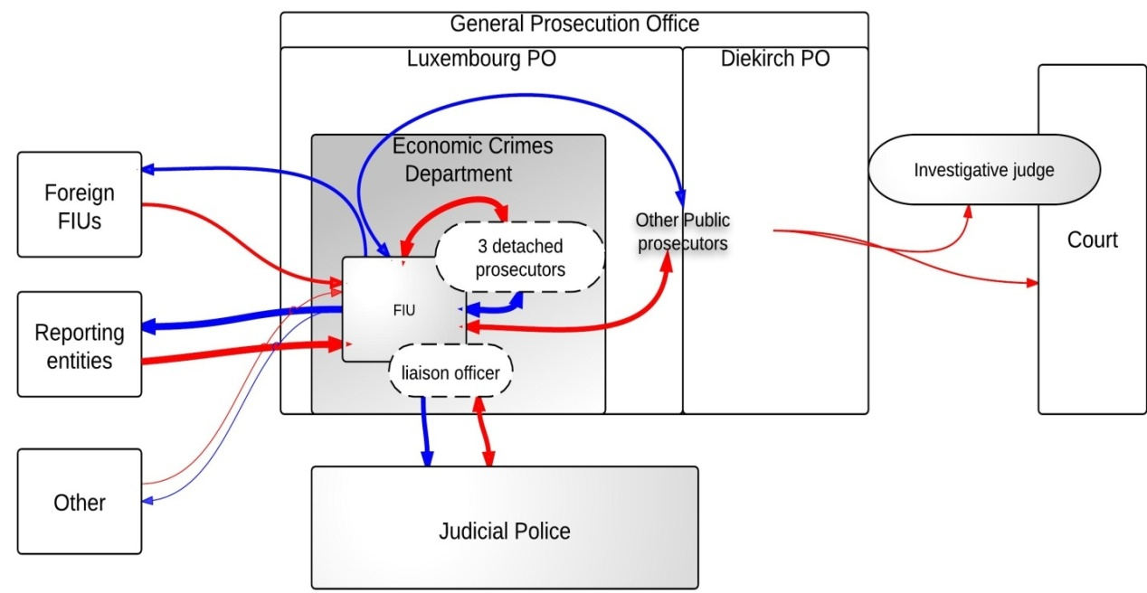

*Legend: In the figure above the red arrows show the ML/TF flows of information; blue arrows represent the feedback given and received by the FIU; the thickness of the arrows reflects the intensity of the information flows –in terms of both quantity and quality; shaded boxes are used to designate those departments/offices/institutions that have a higher level of specialization in dealing with ML/TF cases.*

On the matter of feedback, since the FIU is of a judicial nature, it goes without saying that the FIU is well informed on the outcome of its analysis. On the matter of ML specialization, the FIU is such a specialized unit. Furthermore, prosecutors of the economic crimes department as well as the investigative judges working together with the FIU are reported to have extensive experience of prosecuting financial crimes.

In Luxembourg, the investigative judge is empowered to make use of special investigative techniques and other coercive measures against the suspect during the investigation. It is therefore the more complex and complicated cases that are transferred to an investigative judge, because in general in the more complicated cases there is a need for coercive measures. If the prosecutor sees no need to use coercive measures, he/she can prosecute the case. In Luxembourg there are approximately three or four investigative judges out of a total complement of 13 investigative judges that are de facto specialized in ML. They are however not assigned by law to deal with ML cases, but receive the ML cases due to their extensive experience in this field.

As was explained to us during the interviews, one of the historical and institutional reasons for the usage of an investigative judge in Luxembourg is that, essentially, the prosecution is not seen as an impartial assessor of the situation in which the suspect is involved. The prosecution and the legal team of the defence are situated at the same level in court and have conflicting interests. The judge, however, has to be fair and impartial and has to investigate solely on the facts and search all elements in favour or disfavour of the suspect. Therefore, while the investigative judge has the power to introduce coercive measures in the course of a pre-trial investigation, he/she is considered to be impartial and independent. According to the Luxembourg representatives, this means that there is no discussion about abolishing this position in the judiciary.

**8.5.18 Malta**

The FIU receives most of its STRs from the reporting entities and after the analysis forwards them to the Money Laundering Unit within the Police. The FIU does not forward any of its reports directly to the Attorney General’s Office (AGO), as seen below.

**Figure 8.22: AML/CTF Information flow in Malta**

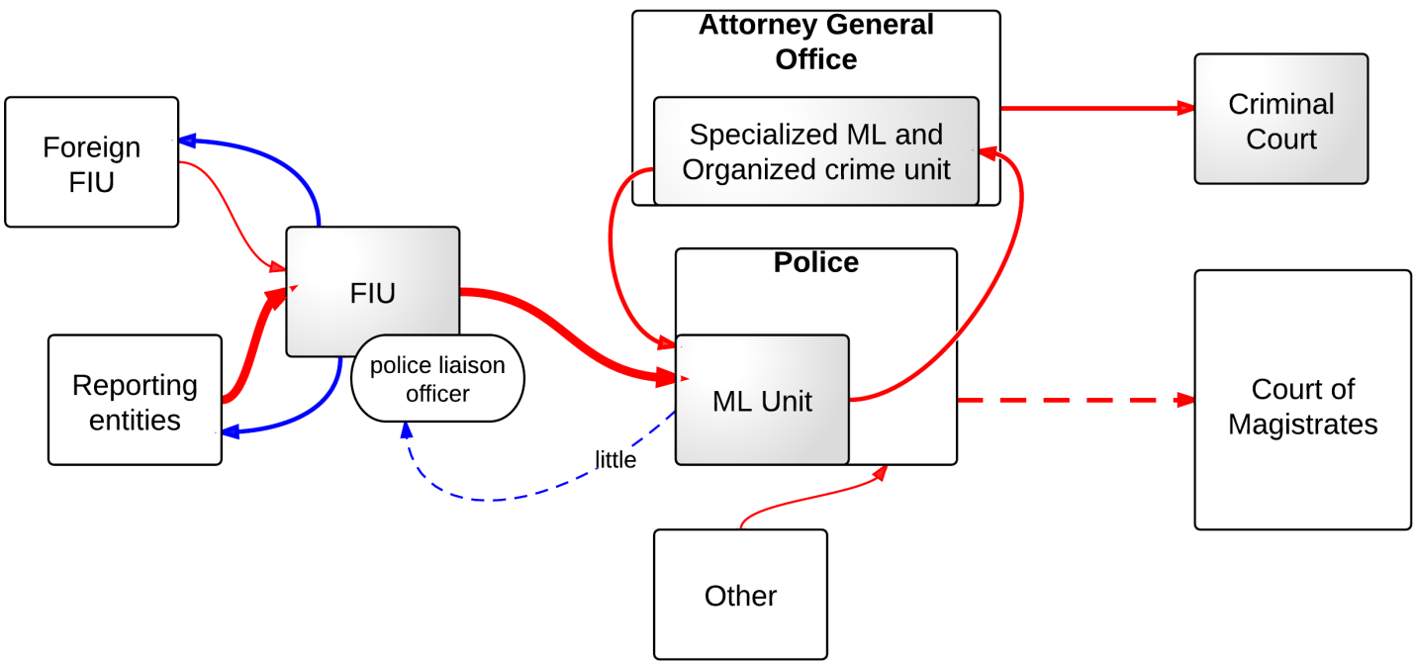*Legend: In the figure above the red arrows show the ML/TF flows of information; blue arrows represent the feedback given and received by the FIU; dotted arrows mark intermediated flows (feedback); the thickness of the arrows reflects the intensity of the information flows – in terms of both quantity and quality; shaded boxes are used to designate those departments/offices/institutions that have a higher level of specialization in dealing with ML/TF cases.*

The pre-trial investigation and prosecution in Malta are done by the police force. Within the police there exists a specialized unit for investigating ML cases. The unit is made up of two investigating teams, each staffed with one inspector and two constables. Money laundering investigations are initiated by the money laundering unit following a suspicious transaction report from the FIU or from other sources, such as the general public, the Attorney General or other police sources. Following the initial investigations, where the investigators see that there is a prima-facie case of money laundering, the police send a request to the Attorney General. If the latter considers that there are sufficient grounds for suspicion, he files a request in the criminal court before a judge. The judge decrees and issues the investigation order and/or the attachment order as the case may be.

The Attorney General’s Office has assigned money laundering cases, organized crime and international cooperation in criminal matters to a unit which provides for specialization in these fields. The unit is made up of a senior counsel to the republic and a lawyer. Both the police and the AGO can prosecute. If the police prosecute the case, the case will be tried before the court of magistrates. Otherwise, if the AGO prosecutes, then the case can also be tried in front of a specialized criminal court if the AG deems so necessary and otherwise it will be tried before the lower court.

The FIU receives feedback from the police on the cases it forwards to them. The Maltese representatives argue this is an informal discussion that is not always mediated by the police liaison officer. However, the police liaison officer does take an active role in advising the FIU on investigative techniques and on LEA-related issues.[52] There is no formal channel of discussion with the PPO. The FIU deems feedback important and would like to see more feedback from the police and from the prosecution units – especially with respect to the outcomes of the cases investigated by the FIU. This, according to the Maltese representatives, is very important for boosting the morale of the FIU agents and increasing their dedication to fighting money laundering and terrorist financing cases.

**8.5.19 The Netherlands**

The FIU-NL receives UTRs from the reporting institutions. The analysis of UTRs consists mainly of matching the UTR information with other information the FIU has access to. Where the FIU finds evidence of suspicion, the UTR is classified as an STR and loaded onto the second database – the STR database. The latter can be accessed by law enforcement authorities for criminal investigations concerning any crime, not only ML/FT. The FIU mostly re-labels the UTR STR once it finds a match for the UTR in the police database (called VROS). Alternatively, the FIU can transform a UTR into an STR if suspicion arises once a foreign FIU makes an inquiry that matches the UTR database. Finally, according to the PPO representative, if the police in the course of another investigation have reasons to suspect that a person has been laundering funds, they can notify the National Prosecution Officer (NPO) for ML and request financial information on the suspect. The NPO has to evaluate this claim and if it deems it justifiable, it will ask the FIU to check their databases for other information related to this person. The FIU will then have to check their UTR database and transform any possible existing UTRs on the suspect into STRs.

The authorities explained that the rationale of the process for the substantiation of a UTR into an STR is to determine whether the transaction-related information is ‘relevant’ to the law enforcement authorities and to establish a link between the UTR and any criminal activity.[53] After authorization, the competent authorities have digital access to the information in the STRs database, through an internet portal (IVT). According to the FIU representative, this is how the FIU-NL disseminates information.[54]

The Dutch prosecutors have an independent position. They do not fall under the authority of the Ministry of Justice with respect to prosecution policy. The General Prosecution Office (hereafter the OM) is the only structure that can order prosecutors to prosecute. The National Prosecution’s Office (hereafter the LP), the Financial, Environmental and Food Safety Offences Prosecution Office (hereafter the FP) and the Regional Prosecution’s Offices (hereafter the APs) are under the umbrella of the OM. There is no formal hierarchy between the LP, the FP and the APs. However, there is an informal hierarchy when it comes to specific crimes. The NPO formulates instructions on handling ML cases: ‘*aanwijzingwitwassen*’. These are sent to the OM, who thereafter issues instructions on handling ML cases that have to be implemented by the prosecutors at the APs. Nevertheless, every AP has to prosecute ML cases should they encounter them.

The NPO attends weekly meetings at the FIU where matters concerning the STR database are discussed. On the issue of feedback, the prosecution cannot disclose case-by-case information to the FIU on how their information has later been used in the criminal investigation. Feedback nevertheless is given on the issue of typologies, the usefulness of STRs, whether they were complete etc. According to the FP representative, feedback is generally given in an informal way and cooperation between the FIU and the FP is very good. Furthermore, the FIU also receives feedback from the specialized investigation authorities and from the police through the liaison officers it employs.

**Figure 8.23: AML/CTF Information flows in the Netherlands**

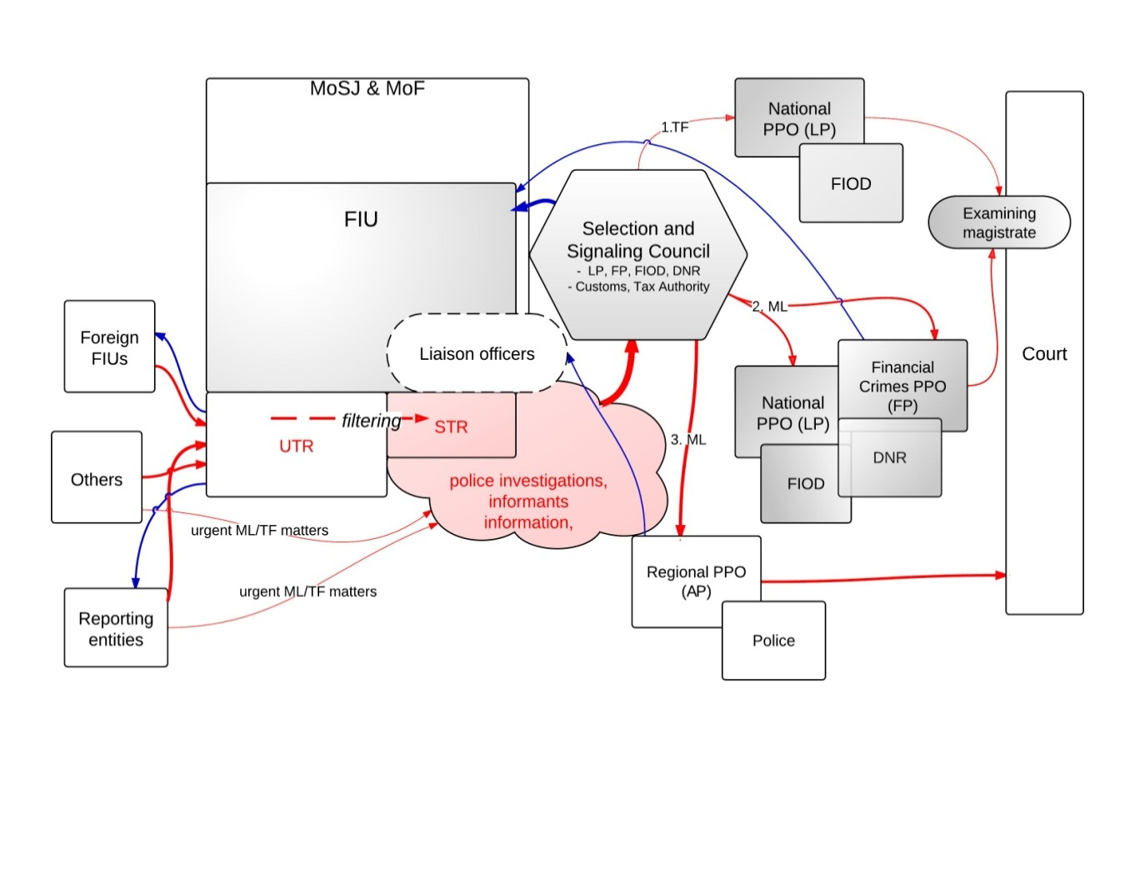

*Legend: In the figure above the red arrows show the ML/TF flows of information; blue arrows represent the feedback given and received by the FIU); the thickness of the arrows reflects the intensity of the information flows –in terms of both quantity and quality; shaded boxes are used to designate those departments/offices/institutions that have a higher level of specialization in dealing with ML/TF cases. Pink clouds designate the ML/TF database simultaneously available to multiple agencies (law enforcement and FIU) which is commonly used as the departure point for ML/TF criminal investigations.*

In the Netherlands there are several specialized investigative authorities: the FIOD is a subdivision of the Tax and Customs Administration and focuses on fraud, organized crime and the financing of terrorism. The National Crime Squad (DNR) is a unit of the national police force and is responsible for combating organized crime and serious crime. DNR carries out all its investigations under the authority of the LP or of the FP.[55]

The FP, LP, FIOD and NR work together on ML cases. All parties have earmarked capacity for ML cases. Members of all parties sit together in a Selection and Signalling Council ‘S&S overleg’ (hereafter the S&S Council). The role of the S&S Council is to scan all sources of information (the STR database, cash/drugs police confiscations, MLA requests, information provided by the tax authorities etc.) and to detect possible ML cases. According to the FP representative, the financial analysts sitting in this council are often capable of detecting complicated financial structures and transform many STRs into successful prosecutions. Additionally, another important role of the S&S Council is to distribute ML cases to the most competent authorities, given the nature of the cases.

According to the LP representative, APs do not receive their information from the S&S Council. Furthermore, not all criminal investigations in the Netherlands have an STR as their basis. Informants are a valuable source of information on which the prosecution can build a criminal investigation.

In general, the APs prosecute the ML offence as well as the predicate offence. The LP and the FP, however, focus on more specific crimes. According to the LP representative, the LP handles investigations involving large drug cartels and human trafficking and the financing of terrorism. The FP, however, focuses on financial and economic crimes. With respect to ML, both the LP and the FP focus only on the ML prosecution, so in this sense are specialized units for handling ML cases. There are eight teams (approximately 140 detectives) working only on ML cases under the supervision of the LP and of the FP. The DNR has a dynamic team focusing on underground finances, and two focusing on large drug cases. The FIOD has among other things a team handling drugs at the largest airport, Schiphol, and teams that do not focus only on ML cases. Furthermore, there are COMBI teams where the DNR and the FIOD work together, which are mainly targeted at investigating and prosecuting facilitators.

On the issue of the way ML specialization of the judiciary is achieved, this is mostly done in a learning-by-doing manner. Prosecutors and judges can also attend courses on financial investigations, where ML is also discussed. According to the FP representative, in the Netherlands, every prosecutor should be able to prosecute ML cases. A financial background is useful in understanding financial sheets but is not a requirement once there is competent complementary financial advice, i.e. as long as financial experts can make the bookkeeping investigations.

The approval of an examining magistrate (‘*rechtercommissaris*’) is required if the prosecution wants to make use of certain special investigative techniques: questioning of witnesses who do not want to give a statement to the police, recording confidential information, investigating telecommunications and gathering information covered by professional secrecy from notaries and lawyers. Cooperation with examining magistrates is, according to the FP representative, easy and fast. Examining magistrates are not specialized in ML matters, but in general have financial crime expertise.

**8.5.20 Poland**

The Polish AML/CTF system is composed of the reporting entities, the FIU and the cooperating units – including the supervisory authorities and the law enforcement authorities.[56] According to the AML/CTF Act, the obliged entities and the cooperating units must inform the FIU when they suspect money laundering or terrorist financing. The FIU thereafter checks these reports against the databases it has access to, and if suspicion is confirmed, the FIU forwards the case to the PPO. The law enforcement authorities can submit a report to the FIU in relation to another crime under investigation if they consider that there could be a connection to ML or TF.[57] When the FIU considers that the report has been correctly submitted, it will try to provide the respective LEA with additional information to support its investigation. After the FIU has conducted its investigation, it will therefore forward the case to:

1. the PPO, when it finds the suspicion of money laundering or terrorist financing is justified
2. the LEA, when it has information about other criminal offences in connection with money laundering that need further investigation (i.e. police, border guards, fiscal control, anti-corruption bureau etc.)

According to the Polish representative, in 2009 the FIU forwarded 180 cases to the PPO and 246 cases to the LEA. Furthermore, in 2010 the FIU forwarded 195 cases to the fiscal control offices, 122 cases to the police (including the Central Bureau of Investigation), 89 cases to the Internal Security Agency (including the Anti-Terrorist Centre), 7 cases to Border Guards, 6 cases to the Central Anticorruption Bureau, and 1 case to the tax authorities.[58]

**Figure 8.24: AML/CTF information flows in Poland**

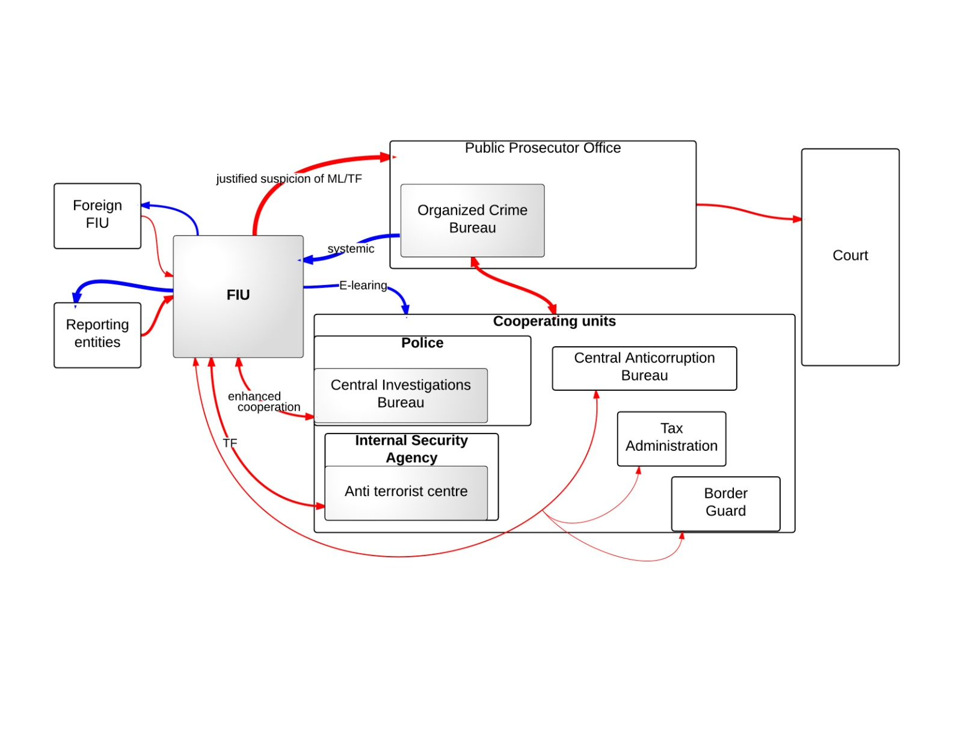

*Legend: In the figure above the red arrows show the ML/TF flows of information; blue arrows represent the feedback given and received by the FIU; the thickness of the arrows reflects the intensity of the information flows –in terms of both quantity and quality; shaded boxes are used to designate those departments/offices/institutions that have a higher level of specialization in dealing with ML/TF cases.*

In terms of feedback, the PPO and the law enforcement authorities are required by the AML/CTF Act to advise the GIFI on all cases where they suspect money laundering or terrorism financing. Moreover, the PPO and the law enforcement authorities must also inform the FIU on the initiation and completion of investigations of money laundering or terrorism financing crimes and on the charges imposed, even when these investigations did not start from information provided by the FIU.[59] According to the Polish representative, this provision for cooperation between the FIU and the LEAs is remarkable in the case of an administrative FIU. Together with the systematic feedback it receives, the FIU seems well connected to the other key players in the Polish AML/CTF system.

In general, investigations are initiated and carried out by the police and other entitled bodies but the public prosecutor has the power to take over the proceedings. In general, the PPO supervises the investigation of the police. The public prosecutor must conduct investigations himself, when the suspect is a member of the law enforcement authorities or of the judiciary (a judge, a public prosecutor, a police officer etc.).[60] According to MONEYVAL (2006), money laundering and financing of terrorism cases are investigated by the Central Investigations Bureau of the General Headquarters of the Police. There is no specialised ML unit within the police.

The Polish prosecution is organized in Appellant, Regional and District Prosecution Offices. According to the Polish representative, ML/TF cases can be investigated by the District Prosecutor’s Offices. If a given investigation turns out to be of a complex character (e.g. a large number of entities involved, sophisticated methods of money laundering, transnational criminal scheme), the case is handed over to Regional Prosecutor’s Offices. When a linkage between the ML/TF case and organized crime is found, the case is investigated by the Appellate Prosecutor’s Offices. This division of competences has been laid down in the Ordinance of the Minister of Justice of 24 March 2010 on the internal activities of the units of prosecution service.

According to MONEYVAL (2008) since 2007 the Organized Crime Bureau of the National PPO was divided into a central unit and 11 local departments. The departments conduct investigations into the more serious crimes – terrorist financing, organized crime, money laundering, corruption in the governing bodies and the judiciary. The central unit is responsible for the coordination of the local departments in their AML/CTF investigations as well as for issuing statistics on these matters.[61]

The prosecution can use FIU data in building a case file. The PPO can request information from the FIU when this supports the investigation in progress. Furthermore, the FIU seems to be a central source for ML and TF financing information, as the Polish representative estimates that approximately 60% of all ML/TF prosecutions and approximately 80% of all ML/TF convictions can be traced back to FIU reports.

**8.5.21 Portugal**

A peculiarity of the information flow system in Portugal is the double reporting of the obliged entities. These entities have to report to the FIU and to the DCIAP at the same time and they also receive feedback from both institutions, as mentioned also in the FATF Mutual Evaluation Report.

The PPO does not necessarily start a formal criminal/judicial analysis upon receipt of the reports, but they cross-check their own databases (‘administrative procedure’). The DCIAP can therefore provide the FIU with information on already existing formal inquiries, such as possible ongoing investigations. At the same time, the FIU conducts its own preventive investigation and forwards the outcome of its analysis to the DCIAP, as well as to the police competent in investigating drug-related crimes, the tax authorities concerning tax-related crimes (the main receiver of FIU reports) or the economic and corruption department within the judicial police (when the predicate offence is not known). The FIU always forwards the report to the DCIAP once they have confirmed the suspicion presented in the STR. When there is no confirmation of suspicion, DCIAP is not notified and the case is archived in the FIU database.[62]

**Figure 8.25: AML/CTF Information flows in Portugal**

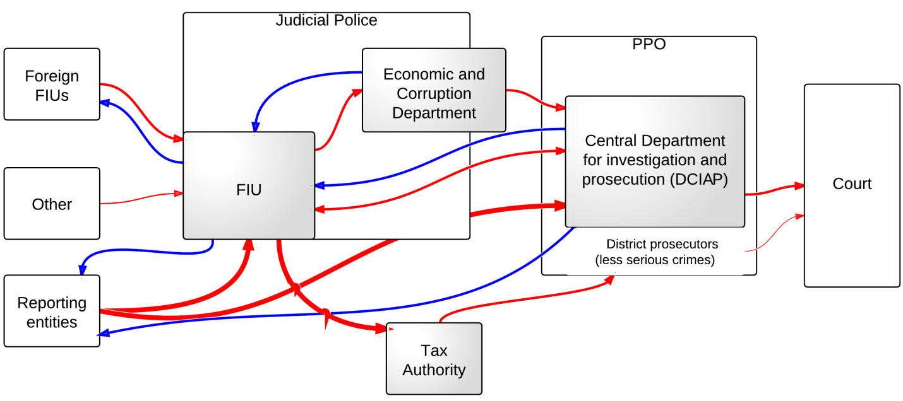

*Legend: In the figure above the red arrows show the ML/TF flows of information; blue arrows represent the feedback given and received by the FIU; the thickness of the arrows reflects the intensity of the information flows –in terms of both quantity and quality; shaded boxes are used to designate those departments/offices/institutions that have a higher level of specialization in dealing with ML/TF cases.*

According to the Portuguese representatives, the Portuguese AML/CTF system is in line with EU models, despite the double reporting system. There is a specialized unit for money laundering in the police service which receives the FIU reports and a specialized unit within the PPO that handles the receipt of STRs and that ensures prosecution of ML and TF cases. According to the Portuguese representatives, the DCIAP handles the more serious money laundering crimes (i.e. the big fraud cases and transnational organized crime, as they are generally related to the big ML cases). The DCIAP staff has had specific training to handle the most complex money laundering cases.

With respect to feedback, according to the Portuguese representatives, the double reporting ensures that the obliged entities receive more feedback. Furthermore, it allows for continuous cooperation between the FIU and the DCIAP which implies that the FIU receives sufficient feedback from the prosecution. As part of the judicial Police, the FIU reported good feedback from the specialized police units it collaborates with.

**8.5.22 Romania**

The Romanian FIU forwards its reports to the PPO and can also forward them to the judicial police. The information held by the FIU is generally taken as a starting point in a criminal investigation as the FIU is an administrative FIU. According to the Romanian representative, the PPO usually asks for additional information from the FIU, such as supplementary analysis of transactions involving suspicion of money laundering as well as information on criminal investigations on money laundering that do not originate from an FIU report. In Romania, the competence for prosecuting ML is divided between three prosecution units – the Directorate for Investigating Organized Crime and Terrorism (DIOCT), the National Anticorruption Directorate (NAD) and other national prosecution offices – depending on the predicate offence. DIOCT is the main specialized prosecution unit dealing with AML/CTF matters. Both the DIOCT and the NAD work with specialized police forces within the Ministry of Interior Affairs.

**Figure 8.26: AML/CTF information flows in Romania**

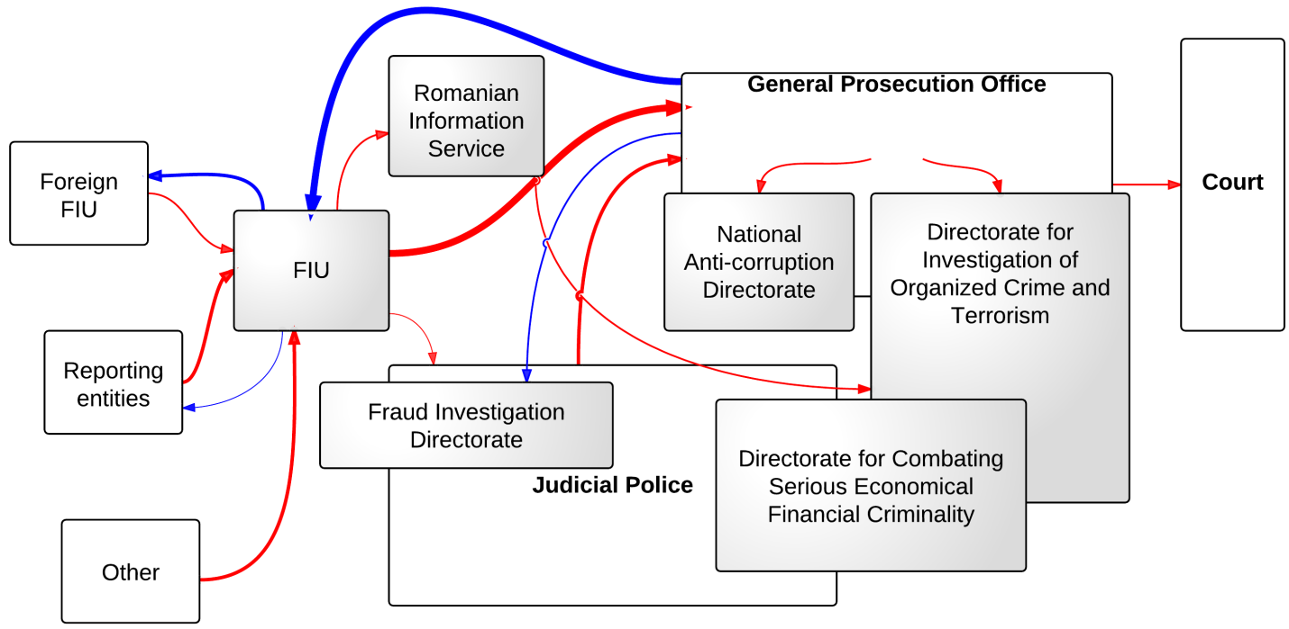

*Legend: In the figure above the red arrows show the ML/TF flows of information; blue arrows represent the feedback given and received by the FIU; the thickness of the arrows reflects the intensity of the information flows –in terms of both quantity and quality; shaded boxes are used to designate those departments/offices/institutions that have a higher level of specialization in dealing with ML/TF cases.*

The FIU receives good feedback from the PPO, although it would like to see this intensified. Having regard to the importance of cooperative relationships between law enforcement authorities and the FIU, at the beginning of 2009, a Cooperation Protocol was concluded between the General Prosecutor’s Office by the High Court of Cassation and Justice (GPOHCCJ) and the FIU on the implementation of the Romanian National Action Plan. The Romanian representatives argue that the feedback reflects good work on behalf of the FIU in terms of the documentation it provides to the investigative authorities. Feedback from the judicial police is limited, but the FIU representatives did not seem concerned as long as the PPOs provide additional feedback.

**8.5.23 Slovenia**

Slovenia has opted for the administrative type of FIU, which does not have police competences, but has a special role in detection and prevention of money laundering and terrorist financing. According to the Slovenian representative, the advantage of such FIUs is the ability to develop trust and cooperation between the FIU and the financial institutions. The OMLP is the administrative office within the Ministry of Finance and acts as a clearing house between the reporting entities and the law enforcement authorities. The OMLP analyses the STRs sent by the obliged entities and if it establishes the reasons for suspicion of money laundering, terrorist financing or other criminal offences, it forwards the gathered data as notification or information to the police or to the State Prosecutor Office for further investigation. OMLP notifications are intelligence data containing sensitive financial data, and not criminal reports in the sense of the Criminal Procedure Act.[63]

Of concluded cases, the OPML forwards to the Criminal Police Directorate of the Ministry of Interior and/or to State Prosecutor’s Office any cases suspected of being connected with the criminal offence of money laundering, together with documentation on the basis of Article 61 of the Slovenian AML/CTF Act. Written information is also sent to the Tax Office and to the Criminal Police Directorate of the Ministry of Interior with respect to suspicion of tax fraud and of the ‘abuse of a position of trust in performing economic activities’.

In 2010 the FIU has mainly cooperated with the Criminal Police Directorate of the Ministry of Interior (Police), with the Special Group of Prosecutors for the Fight Against Organised Crime at the Supreme State Prosecutor’s Office, with the Tax Office, the Customs and with the Slovenian Intelligence and Security Agency.[64] MONEYVAL (2010) also mentions that cooperation between the FIU and the police is very close in AML matters and that, on the basis of a cooperation agreement that the two institutions have signed, they have regular meetings and cooperate on a case-by-case basis. Coordination is arranged especially between the FIU, police and Public Prosecution when more significant cases of money laundering are dealt with.[65]

The State PPO and other state authorities (Criminal Police, Tax Administration, Customs, Slovenia Intelligence and Security Agency) are obliged by law to forward to the FIU all statistics and data on the information provided by the FIU.[66] This is to ensure the centralization and the analysis of criminal data on the offences of money laundering and terrorist financing. The FIU therefore receives annual feedback from the authorities it cooperates with on their findings on the cases forwarded to them by the FIU. Feedback represents an important parameter of efficiency on the part of the OMLP and the police. For instance, on the basis of the feedback received from the Tax Office, the OPML can conclude that it has also played an important role in the field of detection of criminal offences of tax evasion, especially of VAT evasion. [67]

Prior to 2007, the police provided the OPML with feedback informally on the basis of the agreement. After 2007 this obligation was formally stipulated by the new AML/CTF Act. In addition, the prosecutors and the courts twice a year forward statistics on the details of the natural and legal persons that have been investigated/tried and convicted, the nature of the criminal offence, and the amounts that have been forfeited or confiscated.[68]

**Figure 8.27: AML/CTF information flows in Slovenia**

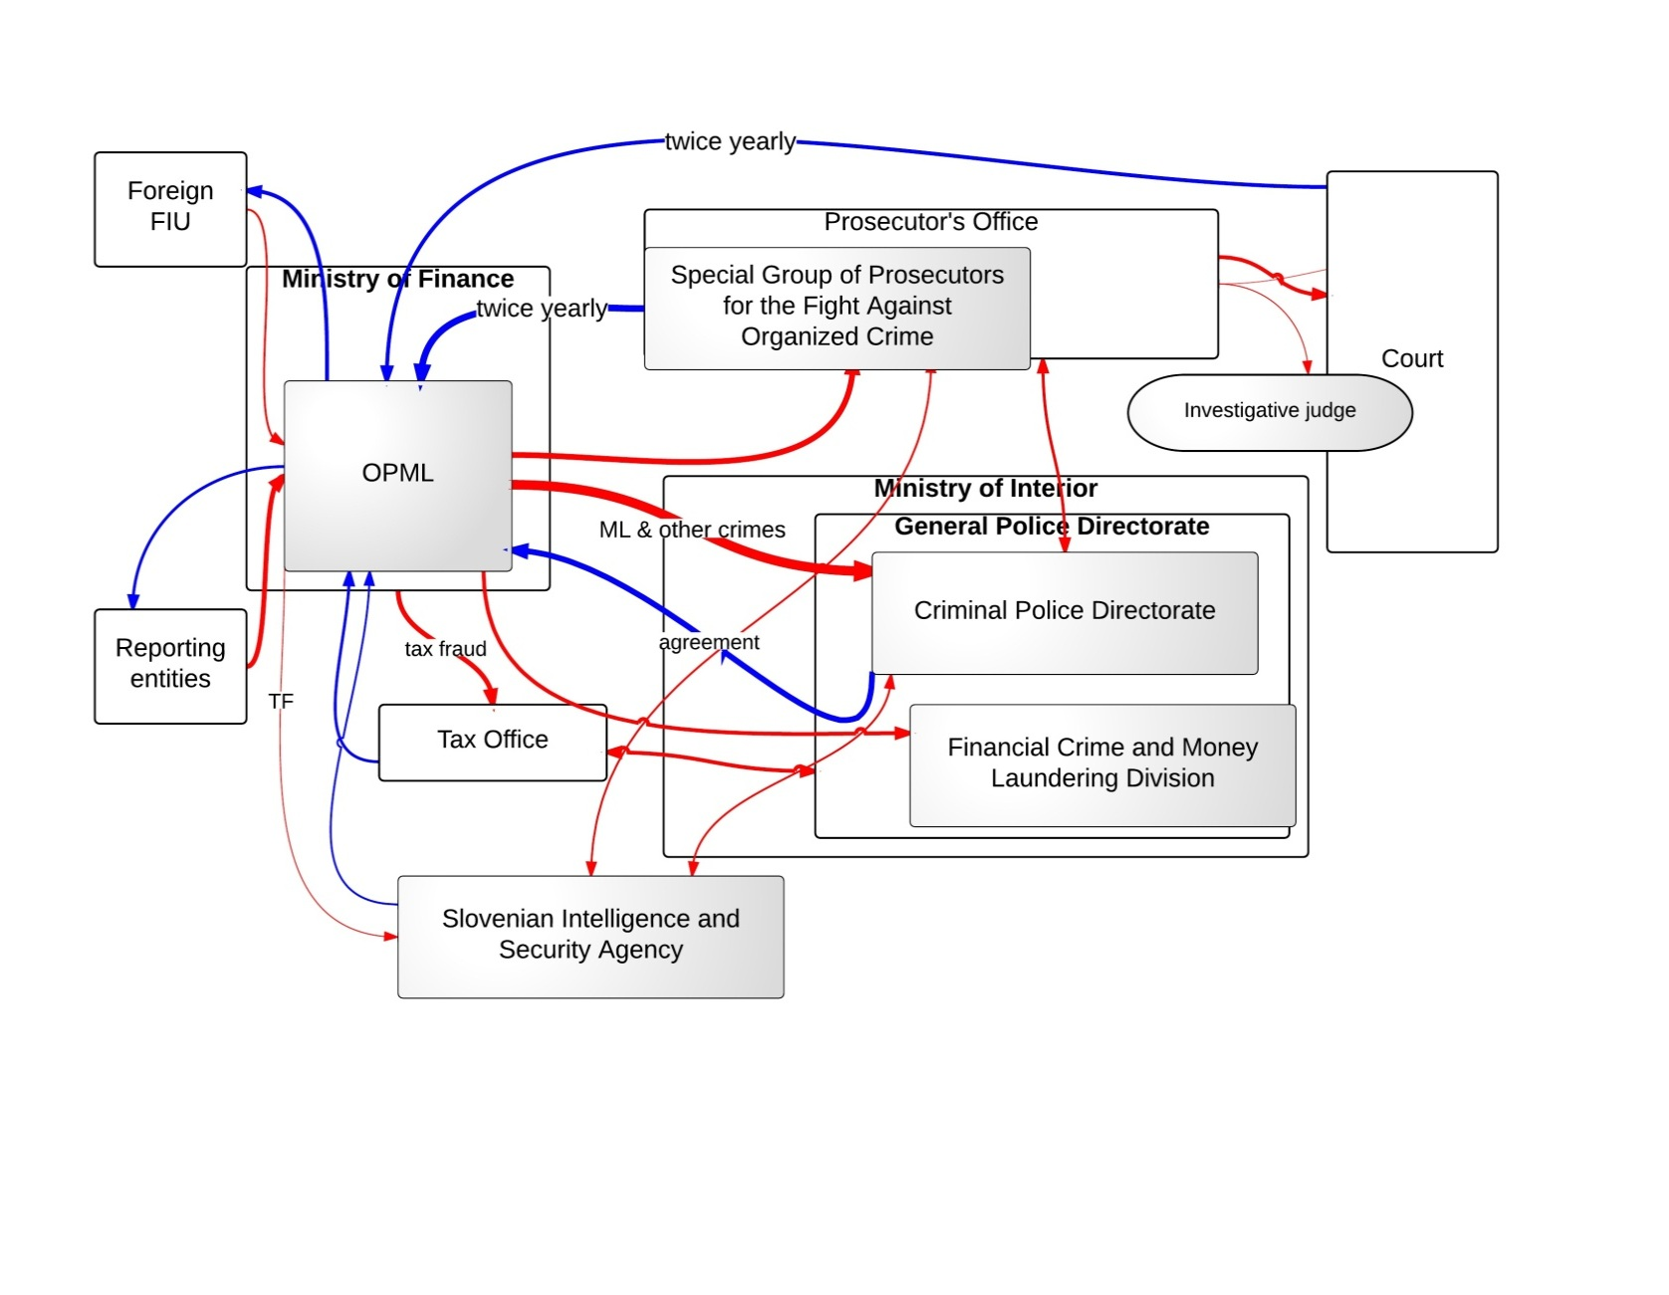

*Legend: In the figure above the red arrows show the ML/TF flows of information; blue arrows represent the feedback given and received by the FIU; the thickness of the arrows reflects the intensity of the information flows –in terms of both quantity and quality; shaded boxes are used to designate those departments/offices/institutions that have a higher level of specialization in dealing with ML/TF cases.*

The Slovenian criminal procedure developed from the so-called mixed (inquisitorial-accusatorial) criminal procedure systems. According to MONEYVAL (2011b), the Slovenian Criminal Procedure Act was adopted by the National Assembly in September 1994 and has already been amended nine times since then, mostly in the adversarial direction.[69]

According to the Criminal Procedure Act, the police are the competent authority for the detection of criminal offences (including money laundering), and the State Prosecutor’s Office is competent in the prosecution of criminal offences. The Criminal Procedures Act allows for the State Prosecutor, in serious cases of economic crime, organized crime and corruption, to establish a special investigative group with other competent institutions from the field of customs, taxes, financial activities, securities, protection of competition, prevention of money laundering, prevention of corruption and illegal drug trafficking. This is mainly to ensure the rapid identification of the criminal offence and the perpetrator and to support the work of the prosecution.[70]

According to MONEYVAL (2011b), an Economic Crime Section has been created under the supervision of the General Police Directorate, within the Criminal Investigation Police. This section includes the Financial Crime and Money Laundering Division, which is primarily responsible for conducting preliminary investigations in money laundering cases as well as in other economic crimes. Within the General Police Directorate an officer coordinates the investigations of money laundering cases of various Police units at a national and regional level. This officer is placed in the Division for Financial Crime and Money Laundering and cooperates directly with the FIU. Two more officers are appointed at each regional police directorate to conduct all financial investigations. The coordinator at the General Police Directorate receives all the notifications of suspicions of money laundering from the FIU. Moreover, on 1 January 2009 the Serious Economic Crime Section was launched within the Police Criminal Directorate. The section has national competence for investigating serious crimes in the field of economic crime, corruption and money laundering.[71]

On the issue of the financing of terrorism, there is a Counter Terrorism and Extreme Violence Division within the Organized Crime Section of the General Criminal Police Directorate that has national competence in the prevention, detection and investigation of terrorist criminal offences (including terrorist financing).[72]

State prosecutors/investigating judges: The state prosecutors are competent in the prosecution of perpetrators and also have the authority to file a ‘motion for conducting the investigation’ with the investigating judge. The investigating judge of the court of jurisdiction conducts the investigation. The investigating judge may entrust the execution of certain acts of investigation to the police.

Based on Article 19 of the Criminal Procedure Act, the state prosecutor is the authorized prosecutor in cases involving offences liable to prosecution ex officio, among which are cases of money laundering and terrorist financing. The state prosecutor directs and supervises the police investigation. The directions the prosecution gives to the police are binding and have to be executed. The role of the state prosecutor is crucial, especially in the most difficult and complicated cases, when according to MONEYVAL (2011b), he/she can significantly affect the legality and success of the police work.[73]

MONEYVAL (2011b) noted the proactive attitude of the OPML, but argued that efforts on the part of the police to proactively pursue money laundering need to increase. MONEYVAL (2011b) argued that the law enforcement authorities might face capacity issues as they pursue few of the cases put forward by the OPML on the money laundering offence. The police and the prosecution instead pursued other criminal offences in the cases forwarded by the OPML. The reason quoted by MONEYVAL (2011b) was a general reluctance to investigate money laundering where there is insufficient evidence of the predicate offence. This impediment could, however, be overcome by means of new case law.[74]

**8.5.24 Slovakia**

The Slovakian FIU receives most of its UTRs from national reporting entities. It disseminates its analysis to the corresponding LEAs in accordance with the provisions of the AML/CTF Act (Sections 26 and 28). Most reports are forwarded to various police units, under the Presidium of the Police Force. If the information that the FIU possesses can be used to initiate tax proceedings, the FIU forwards its reports to the Tax Directorate or to the Customs Directorate. In 2010, less than 9% of the reports forwarded by the FIU contained sufficient information to start a criminal investigation, but the vast majority of the reports had still to be investigated by these police units, which ultimately decide whether the evidence supports the commencement of a criminal procedure or not.[75]

When the evidence is sound, the FIU can propose the commencement of criminal investigations in a money laundering case and has to notify the PPO of this. Furthermore, in its capacity as ARO the FIU has to provide further assistance to the LEAs with respect to the confiscation of proceeds related to a ML/TF investigation.

**Figure 8.28: AML/CTF information flows in the Slovak Republic**

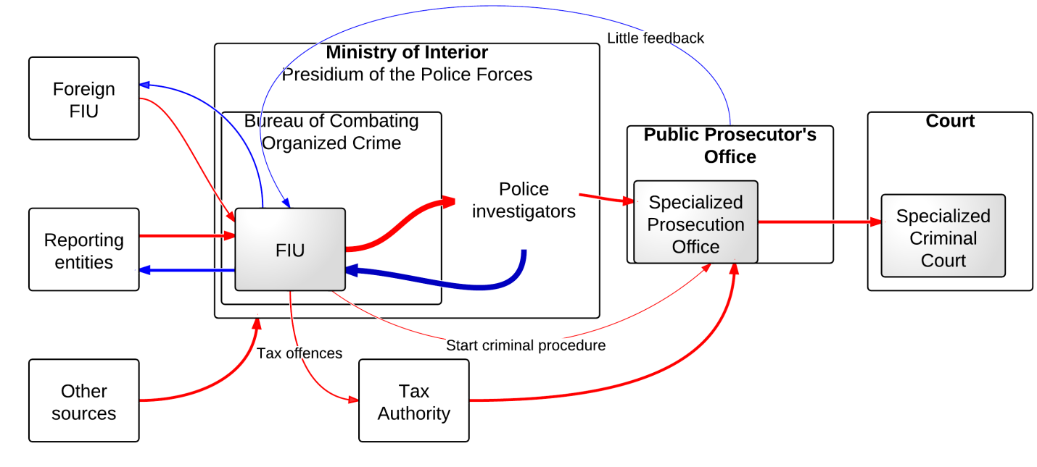

*Legend: In the figure above the red arrows show the ML/TF flows of information; blue arrows represent the feedback given and received by the FIU; the thickness of the arrows reflects the intensity of the information flows –in terms of both quantity and quality; shaded boxes are used to designate those departments/offices/institutions that have a higher level of specialization in dealing with ML/TF cases.*

With respect to feedback, the police units to which the FIU forwards its reports are said to report promptly on the efficiency of such information.[76] The Slovak FIU meets several times a year with the Director of the Criminal Unit of the General Prosecutor’s Office to inform them of the latest AML/CTF trends. From the 2010 FIU report it may be concluded that the FIU is the leading authority in AML/CTF policy, and that closer collaboration between the PPO and the FIU would be beneficial for both institutions from a learning point of view. Unfortunately, according to the Slovakian representative, and confirmed by the MONEYVAL Fourth Round Assessment Visit, the feedback the PPO provides to the FIU is mostly concentrated on statistics, rather than on the background of the prosecutions that were started on the basis of the information provided by the FIU.[77]

With respect to specialization, it seems that Slovakia has introduced specialized agencies at all levels of the repressive enforcement chain. There is a prosecution department handling the most complex money laundering cases as well as a specialized criminal court for more serious crimes.[78]

**8.5.25 Spain**

In Spain, upon receipt of an STR, the administration decides whether the STR pertains to ML or TF. If there are no antecedents on the person, and there is no clear indication of the predicate offence, SEPBLAC – through its liaison officers from the National Police and the Civil Guard – sends the ML reports to the specialized departments of the National Police (UCIC: Central Criminal Intelligence Unit) or of the Civil Guard (UTPJ: The Technical Unit of the Financial Police). If the case is related to the financing of terrorism, it is given to other specialized departments of the National Police (CGI: The General Intelligence Commission) and of the Civil Guard (SI: The Intelligence Service). Should the SEPBLAC notice a clear offence in its investigation, it will send the information to the competent public prosecutor on Anti-Corruption or on Anti-Drugs. This, however, seldom happens.

In Spain, terrorist financing is more often investigated than other EU MS due to the presence of recognized terrorist factions within its territory. It is therefore no coincidence that both ML and TF are investigated and prosecuted by specialized units that essentially work independently as well as with one another. There are two centralized points for the police, who decide whether there is an overlap regarding the investigation, and who is going to perform the final investigation, the National Police or the Civil Guard. These points are mentioned in the Information flow chart as CICO – Centre for Organized Crime Intelligence and CNCA – National Centre for Anti-terrorist Coordination.

**Figure 8.29: AML/CTF Information flows in Spain**

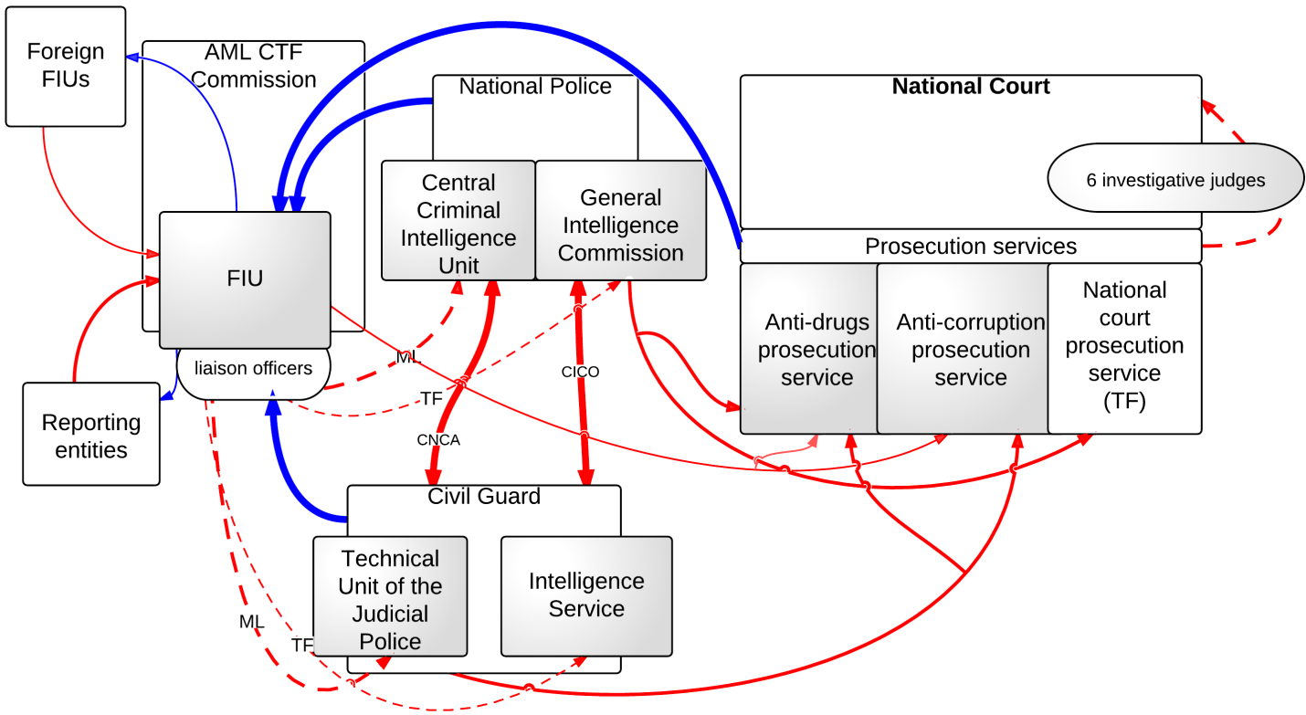

*Legend: In the figure above the red arrows show the ML/TF flows of information; blue arrows represent the feedback given and received by the FIU; dotted arrows mark intermediated flows (feedback); the thickness of the arrows reflects the intensity of the information flows – in terms of both quantity and quality; shaded boxes are used to designate those departments/offices/institutions that have a higher level of specialization in dealing with ML/TF cases.*

In Spain, the prosecution service operates directly under the National Court (‘Audiencia Nacional’) and there are three specialized prosecution services: the National Court Prosecution Service handles TF cases, the Anti-drugs Prosecution Service specializes in prosecution of drug crimes and has a long tradition, and the Anti-corruption Prosecution Service works on the repression of corruption-related offences.

With respect to feedback the FIU is content with the feedback it receives both from the specialized prosecution services as well as from the specialized investigation units it works with. Both the Spanish FIU and PPO representatives argued that cooperation between the two is effective.

**8.5.26 Sweden**

In Sweden, the FIU is an independent unit of the National Police Board. The FIU can choose to forward its cases to the Swedish National Prosecution Authority or to the Economic Crimes Bureau (ECB). The decision of the FIU as to whether to forward an intelligence report to the local police office or to the ECB depends on the size/importance of the case. In Sweden, it is the Prosecutor General who decides if the ECB or the National Prosecution Authority will eventually prosecute the case and, in general, major pre-trial investigations are led by a public prosecutor. In terms of feedback, according to the Swedish representative, the FIU really has to push for feedback. Currently, the FIU is working with the police and PPO on this matter.

**Figure 8.30: AML/CTF Information flows in Sweden**

Supervised Entities

Anyone

FIU

PPO

Court

Economic Crimes Bureau

National Police Board

feedback

feedback

*Legend: The blue arrows represent the information that flows from one agency to another (normally that is a report/case unless it is specified that it only concerns a copy) and the red dotted arrows illustrate supervision and case-specific feedback. We have only looked at feedback directed to the FIU, and therefore this figure excludes all other feedback, i.e. between court and prosecution.*

**8.5.27 United Kingdom**

In 2013 it is expected that SOCA will be merged with the National Crime Agency (NCA). The UK authorities state that the NCA is working through the issues of structure and decisions on structure and design are being clarified. It is still uncertain which other law enforcement agencies will be merged with the National Crime Agency. UK FIU will most likely be positioned in the so-called ‘information hub’ foreseen in the planned NCA structure. Bearing these changes in mind, Figure 8.30 is likely to need significant correction.

The UK FIU receives SARs and consent SARs from the reporting entities and from other entities. From the day the FIU receives a consent SAR it has seven working days to analyse it and to decide upon its consent. There is a special Consent SARs Team within UK FIU that analyses the consent SARs. In the seven-working-day period they may consult other law enforcement agencies for additional information and help in the decision as to whether or not to grant consent.

In addition to the SARs that are analysed by specific teams (e.g. on PEPs, terrorist financing or on corruption), other regular SARs are not actively analysed and only made available in their entirety in the SARs database (ELMER). This database is widely accessible by approximately 80 law enforcement agencies (‘end users’).[79] LEA financial investigators can cross-check data from their investigations against the SARs database. They have full access to the SARs. According to the UK authorities, the UK FIU has developed criteria that need to be met by LEAs to obtain access to the SARs database. The access criteria are strict and organizations and individuals that can make use of the ELMER database have to sign an agreement to abide by the user criteria.

The authorities decided to provide full access for the LEAs to the ELMER database because UK FIU could not manage with the resources it had and currently has, so many SARs to deal with. By providing LEA direct access, the chance that the SARs are actually used and can contribute to an investigation is increased. Also, SARs can pop up at various times in different investigations and can thus be ‘reused’.

On the issue of feedback and cooperation with the LEAs and the reporting entities, the UK FIU representatives mention that the FIU has a special team that maintains relations with the industry and is responsible for creating awareness of the tasks and functions of UK FIU and the value of the SARs Regime: the Dialogue Team. The Dialogue Team also goes to law enforcement authorities and ML supervisors to maintain relations with these authorities and to discuss ‘hot topics’ with them. Furthermore, the UK FIU has a specific contact person in each of the ‘end users’ of the SARs database. These designated LEA staff are the point of contact for the Twice-Yearly Questionnaire and are likely to be contacted if UK FIU seeks contact with a particular law enforcement agency.

**Figure 8.31: AML/CTF Information flows in the United Kingdom**

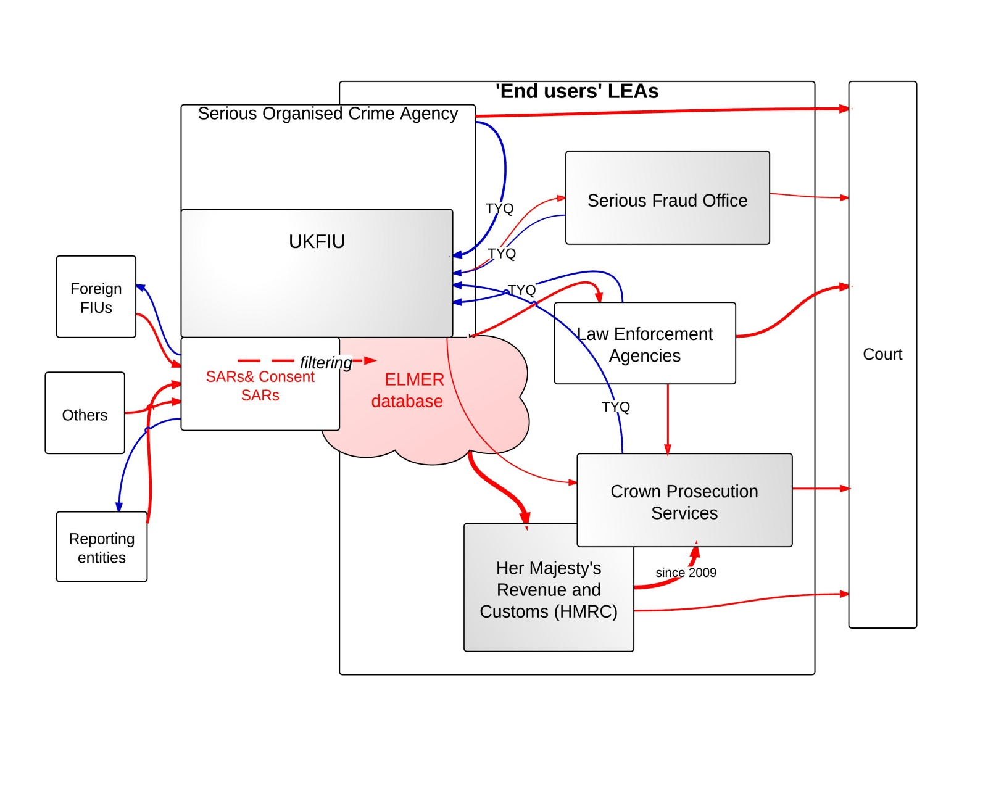

*Legend: In the figure above the red arrows show the ML/TF flows of information; blue arrows represent the feedback given and received by the FIU; the thickness of the arrows reflects the intensity of the information flows –in terms of both quantity and quality; shaded boxes are used to designate those departments/offices/institutions that have a higher level of specialization in dealing with ML/TF cases. Pink clouds designate the ML/TF database simultaneously available to multiple agencies (law enforcement and FIU) that is commonly used as the departure point for ML/TF criminal investigations.*

*Investigative offices and prosecution services handling ML/TF cases*

In the common law system of the UK, public prosecutors do not head an investigation by police or other law enforcement authorities. Investigators are independent and are not instructed by public prosecutors. However, where a case gets more complex or serious (the type of offence), investigators tend to ask prosecutors for advice from the outset of a criminal investigation. This way, Crown Prosecution Services (CPS) is involved almost from the outset of a financial investigation. Investigations can take several years if financial investigative tools are used, due to the complexity of such cases – often various interim measures must be requested of courts and mutual legal assistance may be necessary. For this, investigators need prosecutors to obtain the relevant orders.

The police are divided into 43 local police forces. London has two police forces: London City Police and London Metropolitan Police. The most important law enforcement agencies in the field of AML/CTF policy are SOCA and Her Majesty’s Revenue and Customs (HMRC). Smaller cases are investigated by local police and also tried by local CPS prosecutors. The more serious cases are usually investigated by SOCA and taken up by CPS HQ Central Divisions.

The CPS used to have 42 local CPS areas that coincided with the division of the police forces, but this has recently been reduced to 12 regional teams. Furthermore, CPS has taken over the prosecution functions from DEFRA.[80] In general, there is a move towards positioning the CPS as the single prosecution authority in England and Wales. Until two years ago, CPS only prosecuted cases that were investigated by the police. Since CPS merged with HM Revenue and Customs (prosecution branch), it has taken up prosecutions originally investigated by HMRC – including ML prosecutions[81] There is another prosecution body in the field of AML/CTF policy, which is the Serious Fraud Office. This is a very small prosecutorial body, which only deals with very serious fraud cases where a value of 1 million GBP or more is involved. The SFO has its own financial investigators.

1. This is an online appendix to *The Economic and Legal Effectiveness of the European Union’s Anti-Money Laundering Policy*, Chapter 8.
2. FIU Austria (2011), ‘Annual Report’, p. 11.
3. FATF (2009c)*,* p. 75.
4. Ibid., p. 81.
5. Ibid., p. 81.
6. Ibid., p. 82.
7. Article 34(1) of the Austrian Criminal Procedural Code (StPO).
8. FATF (2009c)*,* p. 80.
9. FATF (2011) *Third Follow-up Report on Belgium*, p. 126.
10. Ibid.
11. However, the provisions of Article 12.4 of the Law for the Measures Against Money Laundering do not specify the required destinations of the information analysed by the FIU. The FIU provides the information to the security and public order services on its own discretion.
12. This project is yet to be carried out; hence a further investigation into the nature and scope of this specialized unit will follow at a later stage of the ECOLEF project.
13. Section 32 paragraph 1 of the new AML/CFT Law.
14. MONEYVAL (2011c), p. 71.
15. Ibid., pp. 71–2.
16. Ibid., p. 76.
17. Ibid., pp. 79–80.
18. Ibid., p. 76.
19. Ibid., p. 77.
20. Ibid.,p. 77.
21. Ibid., p. 85.
22. Ibid., p. 76.
23. The information flow diagram reflects the information available at the time the research was conducted in each Member State. As more detailed information gradually became available, we transitioned to a more detailed information flow diagram style. However, the analysis was not redone for the Member States examined at an earlier stage of the project.
24. Article L.561-23 CMF.
25. Article L.561-29 of the CMF.
26. Act of 9 March 2004.
27. Article 415 Customs offence of money laundering of the Customs Code and money laundering offences under ordinary law, Articles 324-1 to 324-9 of the Criminal Code.
28. Articles 43, 52, 706-16–706-73 of the Penal Procedural Code.
29. Like every other judge, the investigative judge is independent, hence does not fall under the authority of the Executive.
30. FATF (2010e), p. 98.
31. This is to assess whether the STR relates to an offence under Section 261 of the German Criminal Code.
32. FATF (2010e), p. 100.
33. Section 2(7) of the German Criminal Police Act.
34. FATF (2010e), p. 100.
35. FIU Germany (2010), ‘Annual Report’, p. 20.
36. This is despite the fact that the prosecution is governed by the principle of legality. Section 43(2) of the CPC allows the PPO to refrain from prosecuting cases when the documents presented to him/her do not satisfy minimum requirements to ensure the success of the case.
37. According to the Greek FIU representative, there are newly formed specialized groups of PPOs in Athens and Thessaloniki exclusively dealing with financial crimes cases. This has yet to be confirmed by a prosecution representative.
38. MONEYVAL (2010), ‘Third Assessment Report on Hungary’, p. 21.
39. According to Section 26 of the Hungarian AML/CFT Act.
40. MONEYVAL (2010c), p. 57.
41. MONEYVAL (2010c), p. 21.
42. Section 261 of Act IV of 1978 of the HCC.
43. Section 37(3) of the Hungarian Code of Criminal Procedure.
44. MONEYVAL (2010c), p. 149.
45. Ibid., p. 66.
46. Ibid., p. 174.
47. Ibid., p 33.
48. EuroJustice – research on the prosecution systems in the European Union (available at: <http://www.euro-justice.com/member_states/ireland/country_report/443/>).
49. FIU Italy Reports to the NucleoSpeciale di PoliziaValutaria (NSPV) of the Guardia di Finanza (Finance Police).
50. Article 47.1 d) of the 231/2007 Law states ‘[...]the Bureau of Antimafia Investigation and the Special Foreign Exchange Unit of the Finance Police[...] will inform the National Antimafia Prosecutor, whenever it relates to organized crime’.
51. FIU Italy (2010), ‘Annual Report’, p. 7.
52. FIU Malta, available at: www.fiumalta.org.
53. FATF (2011b), p. 91.
54. Ibid.
55. FATF (2011b), p. 39.
56. A simple yet clear and well-structured picture of the AML/CTF system is provided on the website of the Ministry of Finance at [www.mf.gov.pl/en/ministry-of-finance/aml-ctf/system](http://www.mf.gov.pl/en/ministry-of-finance/aml-ctf/system).
57. Articles 31–3 of the Polish AML/CTF Act.
58. FIU Poland (2010), ‘Annual Report’, pp. 10–11.
59. Articles 4(3) and 14.2 of the Polish AML/CTF Act.
60. Euro-Justice Report 2010, p. 603.
61. MONEYVAL (2008), ‘First Follow-up Report on Poland’, p. 9.
62. FATF (2008), ‘Follow Up Report on Portugal’, p. 66.
63. FIU Slovenia (2010), ‘Annual Report’,pp. 2–3.
64. Ibid.,pp. 11–12.
65. MONEYVAL (2011b),p. 61.
66. Article 75 of the Slovenian AML/CTF Law.
67. FIU Slovenia (2010), ‘Annual Report’, p. 10.
68. MONEYVAL (2011b), p. 51.
69. MONEYVAL (2011b), p. 58.
70. Ibid., p. 45.
71. MONEYVAL (2011b), p. 59.
72. Ibid., p. 60.
73. Ibid., p. 61.
74. Ibid., p. 62.
75. FIU Slovakia (2010), p. 14.
76. Ibid., p. 13.
77. MONEYVAL (2011a), p. 68.
78. Ibid., p. 74.
79. As the picture ran the risk of being overcrowded, not all names of ‘end users’ have been included in Figure 8.31.
80. Department for Environment, Food and Rural Affairs. See for the announcement that CPS would take over the prosecution functions of DEFRA. Available at:

    http://www.publications.parliament.uk/pa/cm201011/cmhansrd/cm110712/wmstext/110712m0001.htm.
81. Available at: http://www.cps.gov.uk/your_cps/our_organisation/cfg/the_group/our_history.html.